

Design & Innovation Project (DIP)

Project Report

Smart Monitoring Electronic System for Environmental Noise and Dust

Project Group: E031

School of Electrical and Electronic Engineering

Academic Year 2024/25

Semester 1

Acknowledgement

We would like to express our gratitude to our main supervisor, Associate Professor Chan Pak Kwong, and project lab technician, Mr. Tay, for their support and assistance throughout the period of this Design and Innovation Project (DIP).

Associate Prof. Chan attends each of our DIP sessions to monitor our progress and provide valuable insights. When we encounter challenges, his guidance allows us to view them from fresh perspectives, enabling us to resolve them effectively. His consistent encouragement keeps us on track with our weekly goals, supporting our overall growth as future engineers.

Mr. Tay's support was invaluable as well. In addition to guiding us through lab safety protocols, he actively assisted with our project process. He kept the lab organized, safe and provided a conducive environment for our project meetings.

Table of Contents

Chapter 1 Project Purpose 1

Chapter 2 Project Summary 3

Chapter 3 Project Scope 4

Chapter 4 Environmental Noise and Dust 5

Chapter 5 Overall System Design 10

5.1 Hardware 10

5.1.1 LoLin NodeMCU ESP8266 10

5.1.2 SEN0232 12

5.1.3 GY-BME280 14

5.1.4 PMS7003 16

5.1.5 Li-Po Battery 18

5.1.6 DC-DC Step Up Booster Converter 2.5V - 5V (5W) 20

5.1.7 2x Solar Panels – 6V, 1A 21

5.1.8 Solar Charge Controller Module 6V 2A 22

5.1.9 Custom PCB 23

5.2 Software: ThingSpeak 27

5.2.1 Connecting ESP8266 to ThingSpeak 27

5.2.2 MATLAB Analysis & Visualisations 30

5.2.3 Predicting Sound (dB) Levels 30

5.2.4 Predicting PM2.5 and PM10 Levels 33

5.2.5 Average Predicted Values 36

5.2.6 Visualisation Gauges 38

5.3 Software: Telegram Bot 41

5.3.1 Functionality of Telebot 41

5.3.2 TeleBot Code Structure 43

Chapter 6 Schedule 44

Chapter 7 Cost 46

Chapter 8 Project Outcomes 48

Chapter 9 Project Management Review 50

Chapter 10 Reflection 51

Chapter 11 Acknowledging/Declaring the Use of GAI 54

Chapter 12 References 57

Chapter 13 Appendix A – Members Contribution 60

Chapter 14 Appendix B – General Information 64

Chapter 15 Appendix C – MATLAB & Arduino Code 66

# Project Purpose

According to the World Health Organisation (WHO), noise and air pollution are significant environmental factors that can have detrimental impacts on our health. [14] Air pollution is a complex mixture of particulate matter (PM) that can come from many sources such as cars, industrial plants and many more.

When inhaled, the course PM10 could damage our lungs whereas the finer PM2.5 can enter our bloodstream and cause a multitude of chronic illnesses. A study conducted in Volos, Greece found a positive correlation between PM2.5 levels and the number of patients admitted to emergency departments (ED) for certain respiratory issues as shown in Figure 1. These respiratory issues include Upper Respiratory Infection (URI), Pneumonia and Chronic Obstructive Pulmonary Disease (COPD) exacerbation. [15]

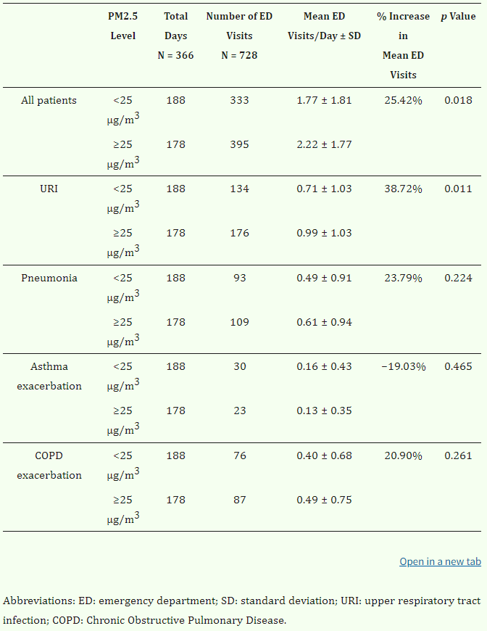

Figure 1 - Correlation PM2.5 levels and ED admissions related to respiratory issues [15]

Noise on the other hand is an underestimated threat that can also cause many long and short term health issues and be damaging to our everyday lives. The WHO has also established that noise is a leading environmental nuisance in the European Region and there have been concerns from the public. [16] Different groups of people react differently to noise exposure. For instance, children are more susceptible to night noises as they tend to sleep longer than adults. Additionally, chronically ill and elderly people are more sensitive to disturbances.

One of the health risks associated with noise exposure is an increased likelihood of myocardial infarction. Figure 2 shows the increasing linear relationship between the probability risk of myocardial infarction and decibel (dB) levels from construction noise of individuals in varying age groups. [17]

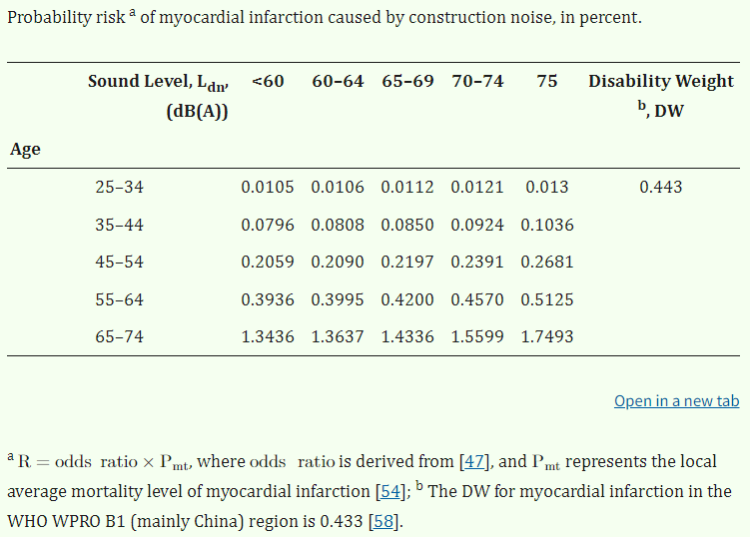

Figure 2 - Relationship between probability risk of myocardial infarction and decibel levels from construction noise [17]

# Project Summary

The main function of this smart environmental monitoring system is to remotely monitor the dust and noise levels of the environment in real time, using machine learning to analyse, predict and alert the user to potentially hazardous environment conditions.

The core of this system consists of a microcontroller, sensors for detecting particulate matter (PM), decibel (dB) levels, temperature and humidity and Internet of Things (IoT) platform for data storage, visualization and predictive analysis through MATLAB. Additionally, a commonly used messaging service is used to send alerts and information to users through their mobile devices. For the system to function remotely, a lithium-ion polymer (LiPo) battery and solar panels are integrated, acting as a power source and harvesting element to allow the system to operate without an external power supply. A custom designed Printed Circuit Board (PCB) is used to connect all the components of the system together allowing the system to be more reliable, durable and compact.

# Project Scope

This project aims to create and design a smart system to monitor environmental noise and dust by combining a microcontroller with an IoT platform. Equipped with sensors for noise, particulate matter (PM2.5 and PM10), temperature, and humidity, the system collects real-time data from the environment and sends it to the ThingSpeak IoT platform. On ThingSpeak, machine-learning models such as autoregressive (AR) and Autoregressive-Exogenous (ARX) modelling are used to analyse and predict future noise and dust levels. The processed data is displayed through interactive gauges and trend graphs, giving users a clear view of current conditions and forecasts.

Additionally, an application programming interface (API), Telegram bot, provides real-time notifications and alerts if noise or dust levels approach hazardous levels. This fully automated system allows users with proactive monitoring tools, enabling them to make informed choices to maintain a healthier living environment.

# Environmental Noise and Dust

Monitoring environmental noise and dust levels has become essential and crucial for public health. Long term exposure with high levels of noise and dust levels can impact health, contributing to several illnesses.

Environmental noise levels are measured in decibel (dB), which indicate how intense a sound is. According to Singapore’s National Environment Agency (NEA) and health organisations worldwide [19][20], there are specific noise thresholds recommended to minimise risks to hearing and overall wellbeing. For example, noise at Normal or Safe levels (below 70 dB) are generally safe even over extended periods, while Very High or Hazardous levels (above 110 dB) can cause hearing damage if the exposure is prolonged.

In this project, we have adapted these threshold levels based on the general guidelines set by the NEA and other health organisations. These guidelines provide recommendations for safe noise exposure, which we have generalised to meet the specific needs of our project.

|  |  |
| --- | --- |
| Sound Level Description | Sound levels in dB |
| Normal | <70 |
| Elevated | 70-90 |
| High | 90-110 |
| Very High | >110 |

Table 1 - Threshold Level for Noise

Environmental dust levels in the air can be quantified by measuring PM concentrations. Particles small enough to be inhaled, specifically those 2.5 μm (PM2.5) and 10 μm (PM10) or smaller, are small enough to be inhaled and potentially lead to various health issues. The NEA uses PM2.5 and PM10 readings to inform the public about air quality, offering guidance on what levels are safe or risky. According to their standards, PM2.5 levels above 55 µg/m³ and PM10 levels over 150 µg/m³ are considered unhealthy. [21][22]

This system of monitoring helps people make informed choices about outdoor activities and understand when preventive measures are needed, creating safer environments for everyone.

|  |  |
| --- | --- |
| PM2.5 Level Description | PM2.5 levels in ppm |
| Normal | <13 |
| Elevated | 13-55 |
| High | 55-150 |
| Very High | >150 |

Table 2 - Threshold Levels for PM2.5 [21][22]

| PM10 Level Description | PM10 levels in ppm |
| --- | --- |
| Normal | <50 |
| Elevated | 50-150 |
| High | 150-350 |
| Very High | >350 |

Table 3 - Threshold Levels for PM10 [21][22]

Temperature and Humidity could also have an impact on these levels of particles. A study in Delhi, India shows that higher temperatures could result in lower PM2.5 levels. Figure 3 illustrates that there are more days with satisfactory air quality at higher temperatures, while lower temperatures are associated with a higher number of days with very poor air quality. Additionally, a higher relative humidity could cause this relationship to have a stronger negative correlation as shown by Figure 4. At higher relative humidity, PM2.5 levels tend to increase more significantly in lower temperatures, while they tend to decrease more in warmer temperatures. PM10 levels also contribute to the overall air quality and is also another form of particulate matter like PM2.5. Therefore, humidity and temperature would be key players in evaluating PM2.5 and PM10 levels. [18]

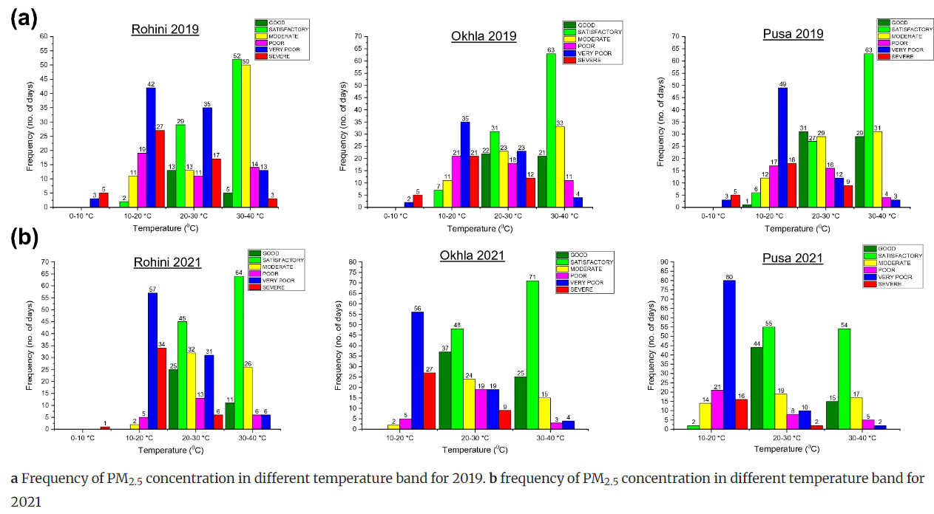

Figure 3 - Correlation between temperature and air quality [18]

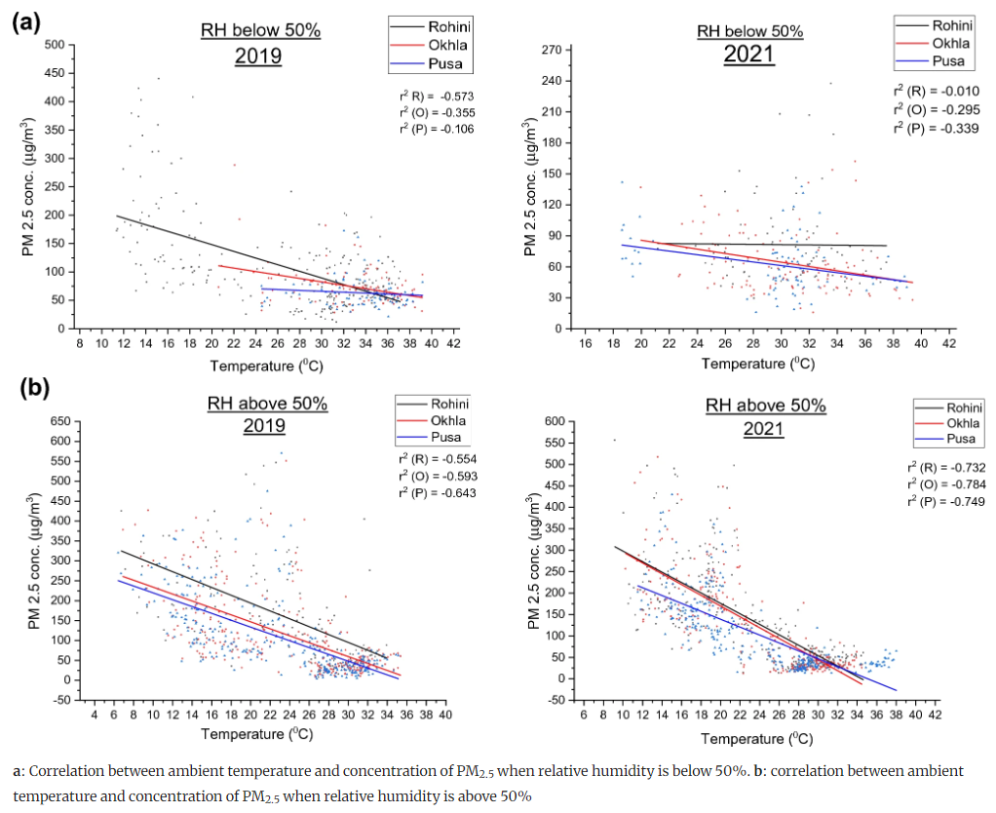

Figure 4 - Effects of humidity on the Temperature - PM2.5 Correlation [18]

# Overall System Design

This project consists of three core components, Hardware, Software (MATLAB) and Software (Telegram Bot). This Chapter will explain each component and how it is used in the overall system design.

## Hardware

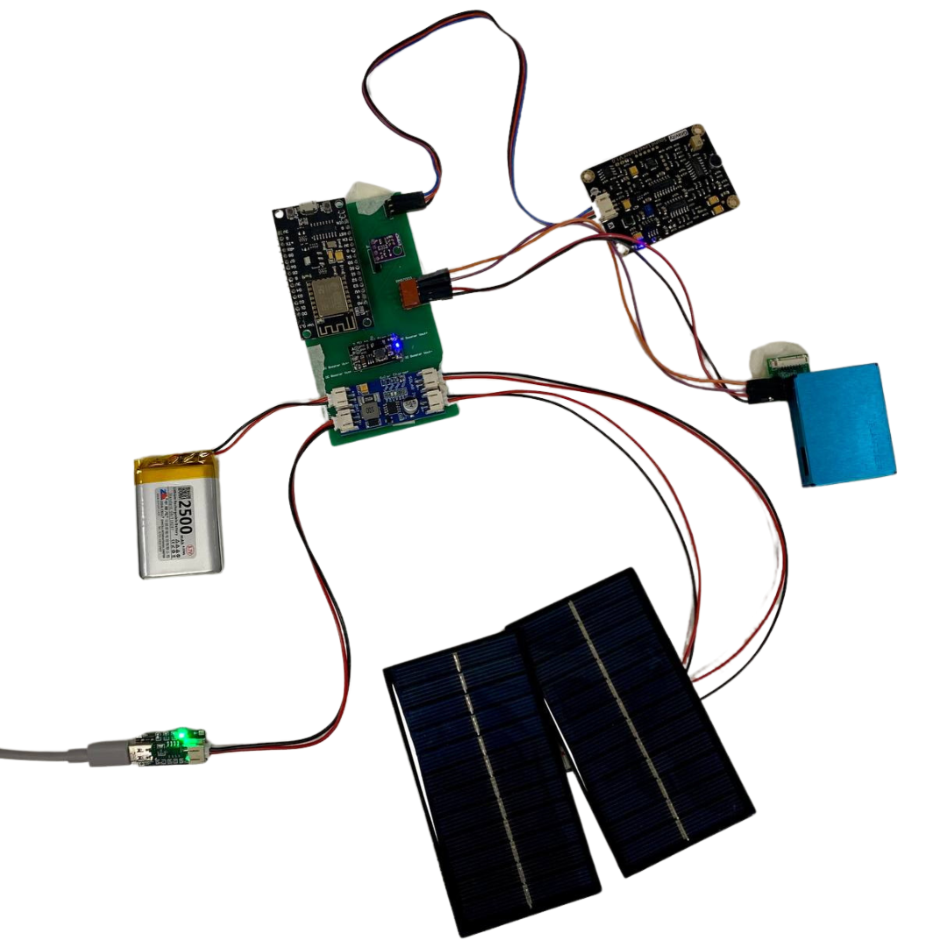

Figure 5 - Complete Connection of all Hardware Component

The hardware side of the project consists of the microcontroller - ESP8266, Sensors - SEN0232, BME280, PMS7003 and Power Supply System – DC step up, Solar Charger controller, Solar Panels, LiPo Battery. All hardware modules used are connected to a custom PCB.

### LoLin NodeMCU ESP8266

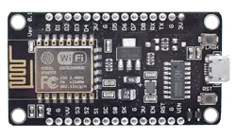

Figure 6 - ESP8266 [1]

#### Function

This microcontroller is widely used for various IoT applications due to its surface-mountable WiFi module with an embedded ESP8266 system on chip (SoC). It is capable for onboard data processing and integration with sensors through general-purpose input/output (GPIO) pins and power supply pins. ESP8266 is programmable with the Arduino integrated development environment (IDE) that has a wide range of libraries that provides extra functionality to the microcontroller. [2]

#### Specification

|  |  |
| --- | --- |
| Core | 1 |
| Architecture | 32 bits |
| Clock Speed | 80Mhz |
| WiFi | IEEE802.11 b/g/n support for WPA and WPA2 |
| RAM | 160KB - 64KB Instruction - 96KB Data |
| Flash | 4MB |
| Digital I/O Pins | 11 |
| Analog I/O Pins | 1 |
| Interfaces | Inter-Intergrated Circuit (I2C) - Serial Peripheral Interface (SPI) - Universal asynchronous receiver / transmitter (UART) - Inter-Integrated Circuit Sound (I2S) |
| Operating Voltage | 3.3V |
| Module Size | 58mm*32mm |

Table 4 - Specification of ESP8266 [1]

#### Justification

The ESP8266 is a low cost and low powered module that has built-in features that are suitable for this project like WiFi and GPIO pins. With this module being able to be programmed by Arduino IDE, it has community and documentation support resulting in a large compatibility with sensors and libraries. Therefore, this microcontroller can allow us to meet the objectives of the project.

### SEN0232

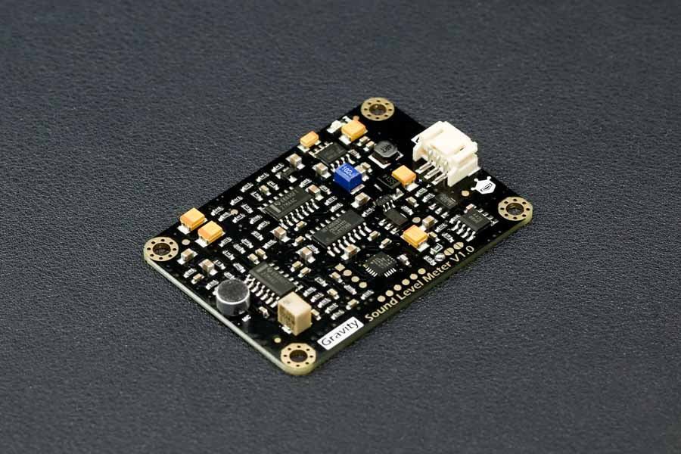

Figure - Analog Sound Level Meter, SEN0232 [3]

#### Function

The SEN0232 is an Analog Sound Level Meter that is designed to accurately measure the sound level of the surrounding environment. This is achieved by using an instrument circuit and a low noise microphone. With a provided connector, this is a plug-and-play component which is user friendly and compatible with a lot of IoT devices due to its wide input voltage of 3.3-5V and outputs a maximum of 2.6V which linearly follows the decibel (dB) value of the surrounding environment. [3]

#### Specifications

|  |  |
| --- | --- |
| Input Voltage | 3.3V - 5V |
| Current consumption | 22mA @ 3.3V, 14mA @ 5V |
| Output Voltage | 0.6V - 2.6V |
| Measuring Range | 30dBA - 130dBA |
| Measurement Error | ±1.5dB |
| Module Size | 60mm * 43mm |

Table 5 - Specification of SEN0232 [3]

#### Justification

Due to its ease of use, wide input voltage of 3.3V-5V and low input current of 22mA at 3.3V, the SEN0232 is an ideal Sound Level Meter to integrate with the ESP8266. It also has a wide measuring range of 30dBA ~ 130dBA with a measurement error of ±1.5dB. The module size is also easy to integrate with its size of 60mm*40mm.

Additionally, from Figure 7 below, the correlation between the decibel (dB) level and voltage output is linear, this simplifies the code without the need for complex algorithms. Suitable for new and experienced students taking on this project.

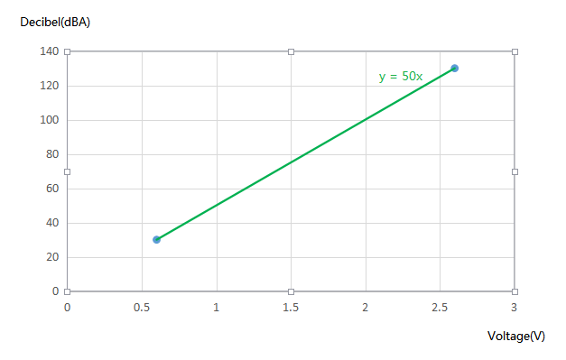

Figure - Relation between Decibel Value and Voltage Output [3]

### GY-BME280

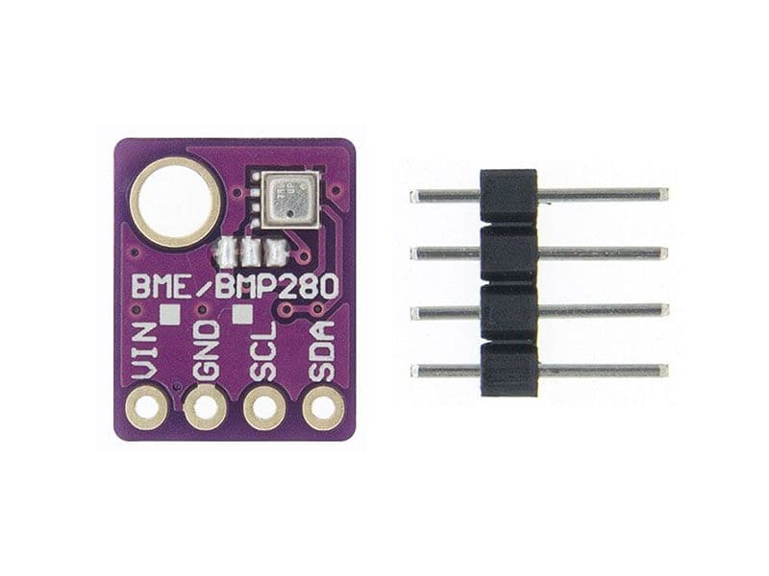

Figure - GY-BME280 [4]

#### Function

This module is an environmental sensor that measures the surrounding pressure, humidity and temperature. Thanks to its low power consumption, it can be easily implemented in battery driven systems. This sensor uses an I2C communication protocol to exchange data with a microcontroller. [5]

#### Specification

|  |  |
| --- | --- |
| Input Voltage | 3.3V - 5V |
| Current consumption | 0.4mA |
| Temperature Range | -40°C to 85°C |
| Temperature Accuracy | ±1°C |
| Humidity Accuracy | ±3% |
| Pressure Range | 300 hPa – 1100 hPa |
| Pressure Accuracy | ±1.0 hPa |
| Module Size | 14mm*11mm |
| Communication Protocol | I2C |

Table 6 - Specification of GY-BME280 [4]

#### Justification

This sensor can operate on a 3.3V source and communicate using I2C communication protocol that the ESP8266 is capable of. This would make the connection very simple. However, to receive readings, an Adafruit_BME280 library needs to be installed and utilized.[5] This is an easy process to complete, and the library allows the code to be readable. The module size is also easy to integrate to any system with its size of 14mm*11mm.

### PMS7003

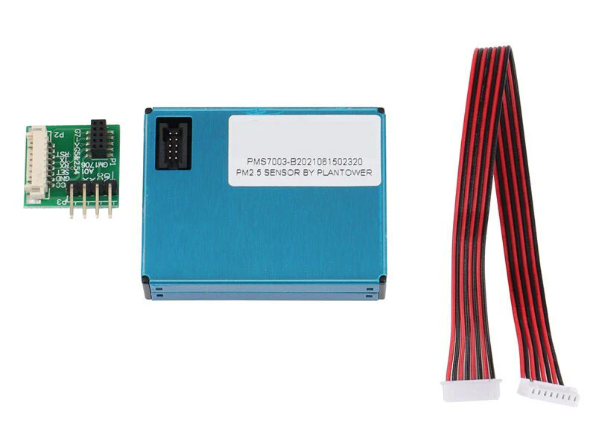

Figure - PMS7003 [6]

#### Function

PMS7003 is a particle concentration sensor that obtains the number of suspended particles in the surrounding air and outputs the result digitally via I2C communication protocol. This is possible by the Laser scattering principle by using laser to radiate suspending participles which then produces scattering. With this, the microprocessor of the module can determine the particle diameter and number of particles based on the MIE theory calculation. Functional Diagram of the sensor can be seen in Figure 10.[7]

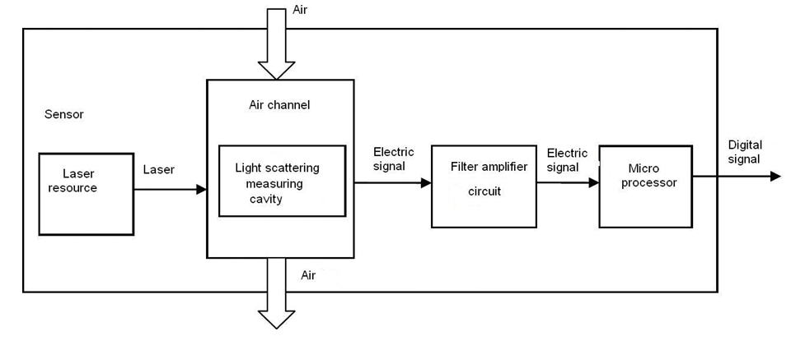

Figure - Functional block diagram of sensor [7]

#### Specification

|  |  |
| --- | --- |
| Input Voltage | 4.5V - 5.5V |
| Current consumption (Active Mode) | ≤100mA |
| Range of measurement | 0.3μm - 1.0μm ；1.0μm - 2.5μm ；2.5μm - 10μm |
| Effective Range (PM2.5 standard) | 0μg/m³ - 500μg/m³ |
| Maximum Consistency Error (PM2.5 standard) | ±10%@100~500μ g/m³  ±10μ g/m³@0~100μ g/m³ |
| Module Size | 48mm*37mm*12mm |

Table 7 - Specification of PMS7003 [7]

#### Justification

This module is sensitive, accurate and reliable and has counting efficiency of 98% for particles larger than 0.5μm. Additional features of zero false alarms and high anti-interference capabilities allow this module to provide consistent data accuracy which makes this module suitable for varying environments. This module also has simple serial digital output that allows easy connection to the ESP8266. Lastly, its slim design allows easy integration into various devices.

### Li-Po Battery

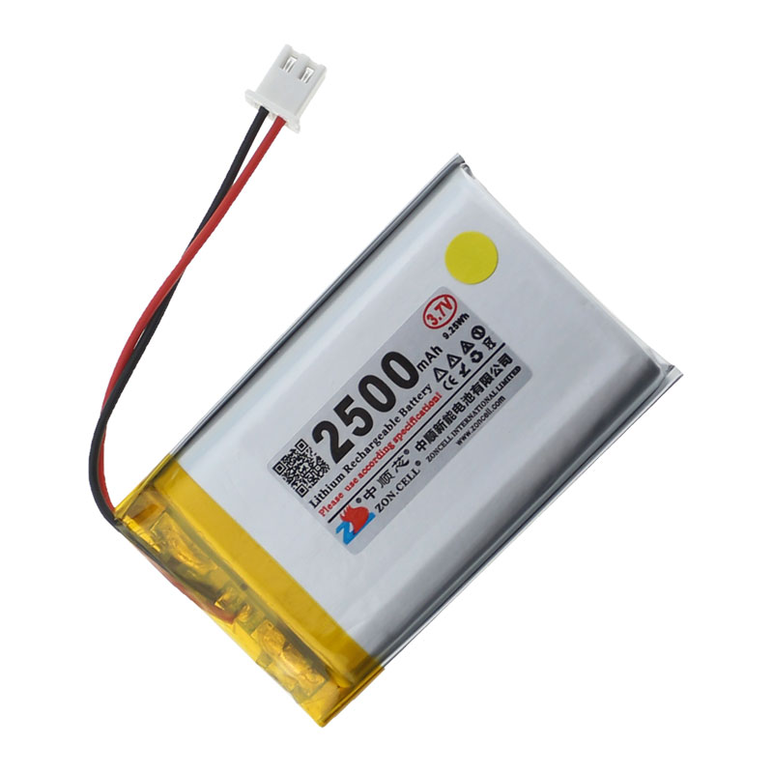

Figure - Li-Po Battery 2500mAh [8]

#### Function

This battery is a compact and rechargeable source that is designed for portable applications that require a power source without the need for external power source. It provides an output voltage of 3.7V that makes it suitable for IoT applications. Its slim profile enables the battery to be lightweight and integrated into compact designs where space and weight are constrained. The battery includes a protective circuit to prevent overcharging which would allow the battery to have a longer life span.

#### Specifications

|  |  |
| --- | --- |
| Output Voltage | 3.7V |
| Working Current (Max) | 1500mAh |
| Battery Type | Lithium Polymer (Li-Po) |
| Connector | PH2.0 |
| Battery Size | 50mm*35mm*10mm |

Table 8 - Specification of Li-Po Battery [9]

#### Justification

To make this system portable, we needed an internal power source that is slim, lightweight and provides enough power to supply the ESP8266. With the ESP8266 and most of the modules used in this system only requiring 3.3V, this battery will be able to supply the required power. For the PMS7003 that requires 5V, a DC-DC step up module is used to output 5V to supply. Solar Panels will be integrated to the system to harvest power to charge the battery.

### DC-DC Step Up Booster Converter 2.5V - 5V (5W)

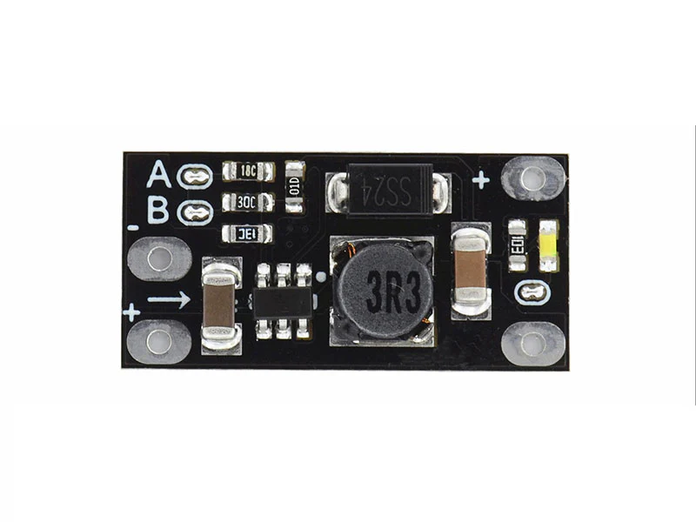

Figure - DC-DC Step Up Booster Converter 2.5V - 5V (5W) [10]

#### Function

This is a module that ultilises a step-up topology to convert the low input voltage, starting from 2.5V, to a wide range of output voltage from 5V – 12V with a maximum power output of 5W. Selecting the output voltage can be done by cutting the A & B traces accordingly. Therefore, this module is useful for other modules that require an output voltage higher than the available source. [10]

#### Specification

|  |  |
| --- | --- |
| Input Voltage | 2.5V - Vout |
| Output Voltage | 5V / 8V / 9V / 12V |
| Output Current | 3.7V Input: 5V 1A / 8V 0.5A / 9V 0.45A / 12V 0.3A  5V Input: 8V 0.7A / 9V 0.7A / 12V 0.5A |
| Module Size | 22mm*11mm*3.6mm |

Table 9 - Specification of Step Up Converter [10]

#### Justification

The main purpose for choosing this module is to provide the correct input voltage to the PMS7003 sensor that requires 5V as the Li-Po battery used in the system is only able to output 3.7V. When this module outputs 5V, it can provide an output current of 1A which is sufficient for the PMS7003 module to operate.

### 2x Solar Panels – 6V, 1A

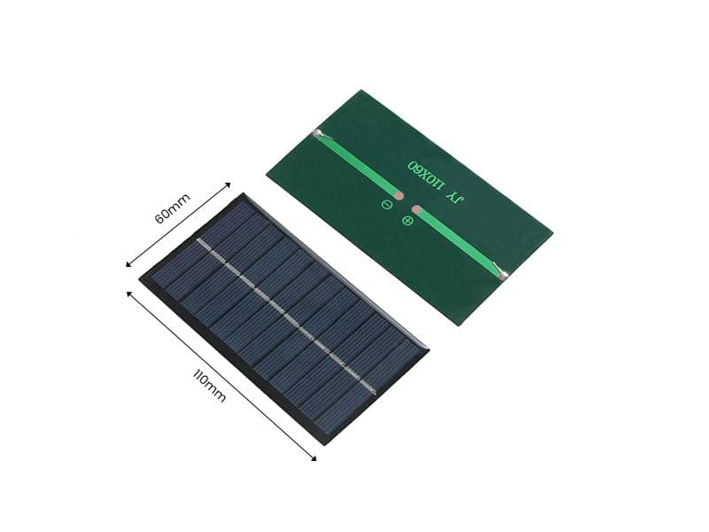

Figure - Solar Panels 6V,1A [11]

#### Function

The solar panel is designed to be a renewable power source that converts sunlight to electrical energy. This solar panel is compact and efficient and can output a maximum power of 1W which makes it suitable for low-powered devices that would be exposed to the sun. When connected to a charge controller, it can be used to charge rechargeable batteries like Li-Po batteries.

#### Specification

|  |  |
| --- | --- |
| Output Voltage (Max) | 6V |
| Power | 1W |
| Module Size | 110m*60mm*2.5mm |

Table 10 - Specification of Solar Panel [11]

#### Justification

To make the system portable and operate in an outdoor environment, a solar panel is needed to charge the internal Li-Po battery. The solar panel is also lightweight and has a durable design which can be easily integrated into most systems. Two solar panels are used to make charging the battery faster which would make the system operate longer.

### Solar Charge Controller Module 6V 2A

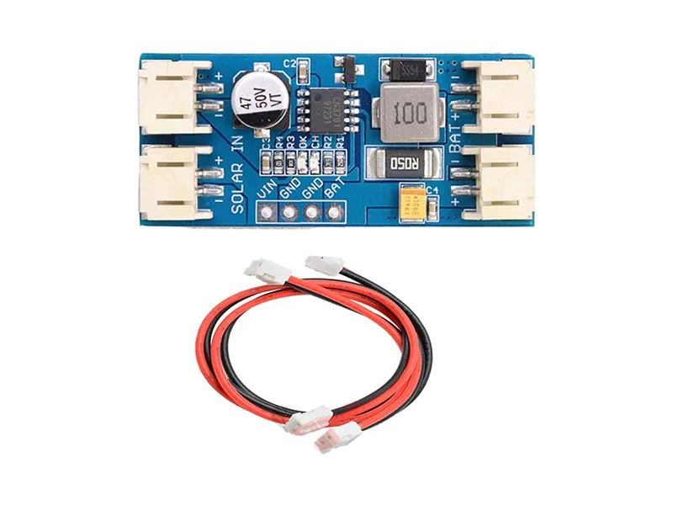

Figure - Solar Charge Controller Module 6V 2A [12]

#### Function

The main function of this module is to regulate the voltage output of a 6V solar panel and manage the charging process of the Li-Po battery with Pulse Width Modulation (PWM). This would ensure that the battery receives a gradual and controlled charge which would result in a long-life span and better performance for the battery. [12]

#### Specification

|  |  |
| --- | --- |
| Input Voltage (Max) | 6V |
| Output Voltage | Nominal 3.7V, Full Charge 4.2V |
| Charging Current (Max) | 2A |
| PWM Frequency | 300kHz |
| Module Size | 45mm*20mm*9.5mm |

Table 11 - Specification of Solar Charge Controller [12]

#### Justification

To charge the Li-Po battery in the system, a controller module is needed. This module works nicely with the solar panel used as it can take up to 6V which is the maximum output voltage of the solar panel. Additionally, the small profile of the module makes it easy to integrate into the system.

### Custom PCB

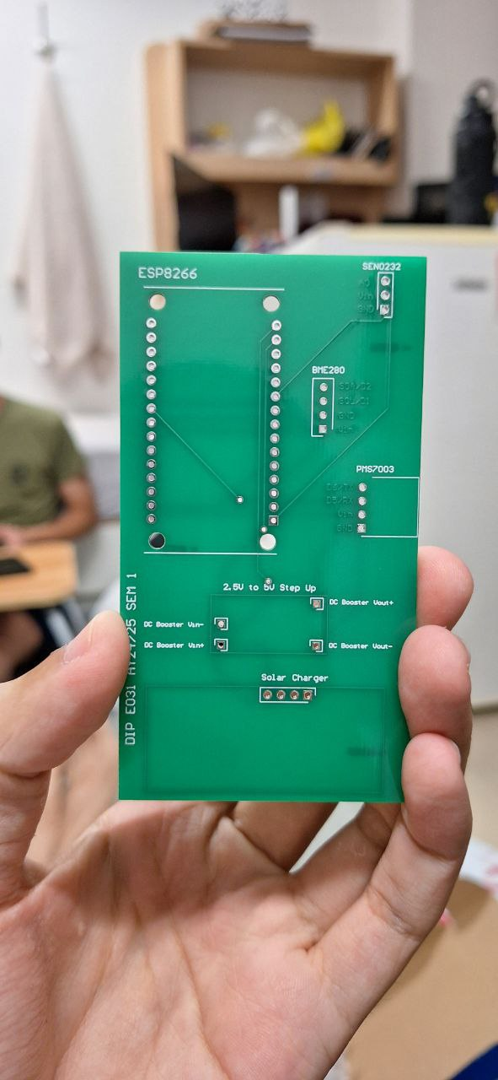

Figure - Custom PCB

#### Function

The function of the custom PCB is to have a more compact and reliable circuit design for the system. By using PCB design software, human errors in the circuit design will be significantly reduced due to the error checking feature. Additionally, the traces in the PCB would be more reliable and are less prone to interference. Minimal soldering is required, and the general look of the circuit would be better.

#### PCB Design Software

Altium Design is a software tool used to create and manage PCB designs. It uses schematic design; PCB layout and 3D modeling to design and manage circuits. Features like auto routing, real-time error checks and extensive component libraries make this software one of the best in the industry. This allows users to create their custom PCB faster while reducing mistakes done by users. Additionally, Altium Design supports team collaboration and version control which is a crucial feature for professionals working together on the same project.



Figure - Altium Designer Logo [13]

#### Schematic Design & 3D Model

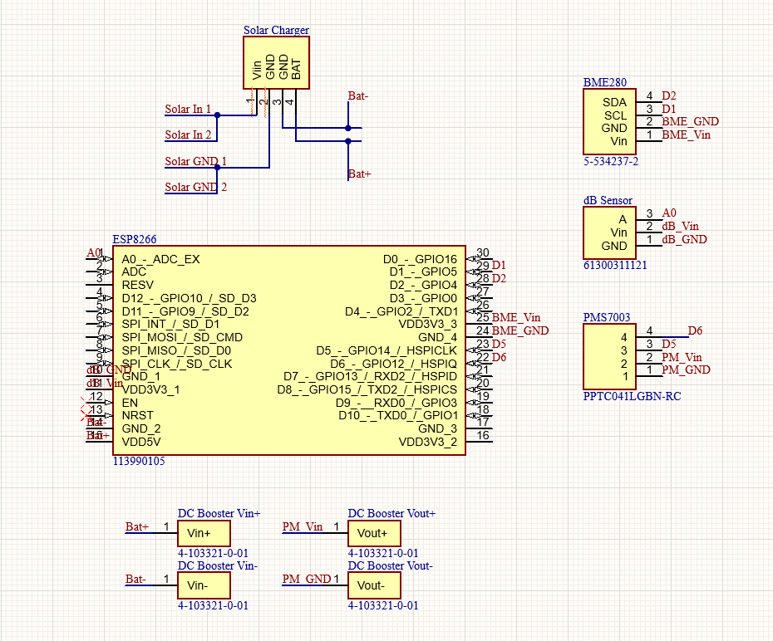

Figure - Schematic Design of Custom PCB (Taken from Altium Designer)

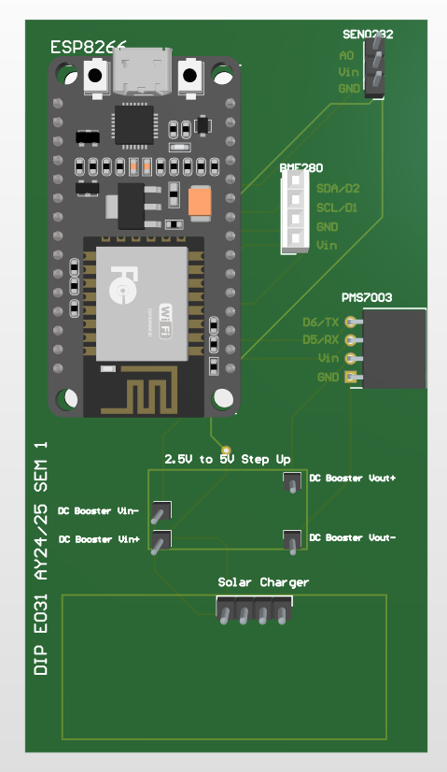

Figure - 3D Model of Custom PCB (Taken from Altium Designer)

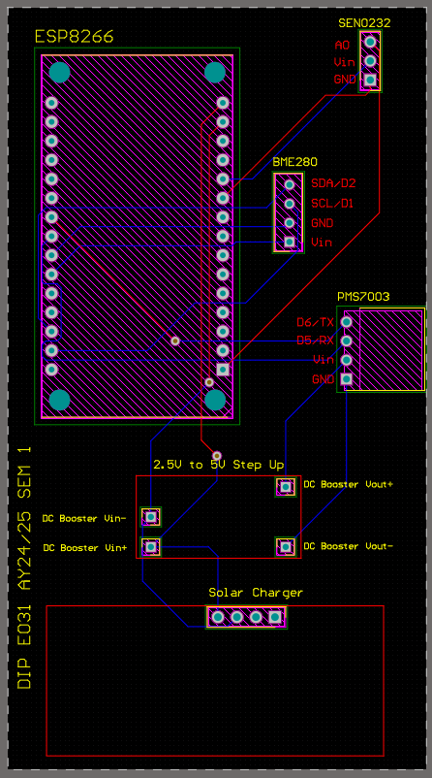

Figure - Traces & Connections of Custom PCB (Taken from Altium Designer)

#### Justification

Custom PCB design is made to help make the system more compact and to increase reliability. This is done by soldering some sensors and modules to the PCB which improves durability. The components are also arranged specifically for optimal placement of each sensor which would make the overall system size to be smaller when compared to using a temporary breadboard for connections. Therefore, the overall system will look neater and easier for broader deployment if needed as PCBs are easy to duplicate.

## Software: ThingSpeak

We have utilised ThingSpeak as a platform for logging data and implementing a machine learning model using MATLAB for prediction analysis. ThingSpeak is an IoT platform which allows users to display, collect data and perform analysis through executing MATLAB code in it. In the context of our project, we use the cloud to store and display our readings of PM2.5, PM10, Humidity and Temperature readings collected from our sensors connected to ESP8266.



Figure - ThingSpeak Logo

### Connecting ESP8266 to ThingSpeak

By setting up a ThingSpeak channel to receive data from multiple sensors, we can build a real-time monitoring system that enables continuous tracking and predictive analysis.

When a new channel is created, ThingSpeak generates unique write and read API keys. The write API key lets us send data to ThingSpeak, while the read API key allows us to retrieve and analyse stored data. In the channel settings, we can define important details like the channel ID and field names. For this project, we have configured Fields 1 through 6 to store specific sensor data as follows:

Field 1: Noise Level (dB)

Field 2: PM1.0

Field 3: PM2.5

Field 4: PM10

Field 5: Temperature

Field 6: Humidity

This setup allows us to store each data type in a dedicated field, making it easier to analyse each environmental parameter individually.

Additionally, a 10-minute delay interval has been included in the loop for transferring data to ThingSpeak. This calibration is necessary because the sensors initially capture data every 15 seconds, which, while useful for high frequency monitoring, can make predictive analysis challenging due to noise fluctuations and affect predictive accuracy. This is because having a high frequency capturing of data can introduce fluctuations which are not significant over longer periods. Furthermore, rapid and frequent capturing of data can lead to overfitting and decreased accuracy in forecasting. By using data points at 10-minute intervals, the model is more likely to capture general trends and long-term patterns, leading to a more accurate and reliable prediction, as well as creating a more stable and suitable dataset that can display trends.

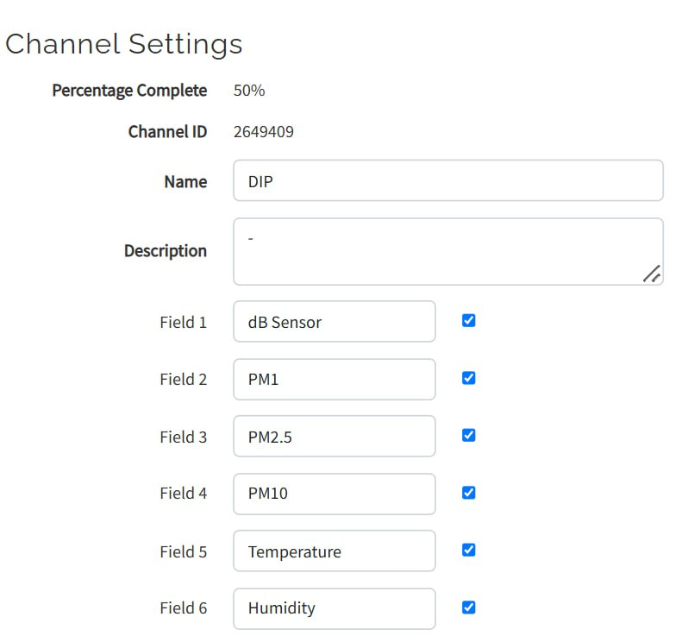

Figure - ThingSpeak Channel Settings

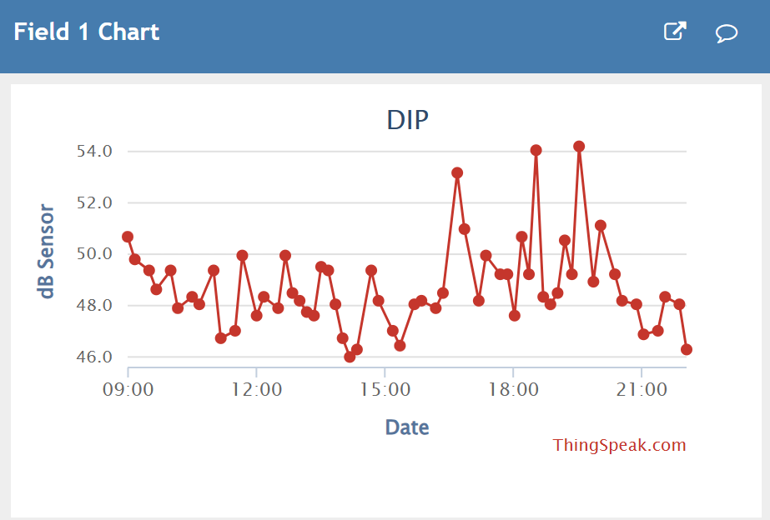

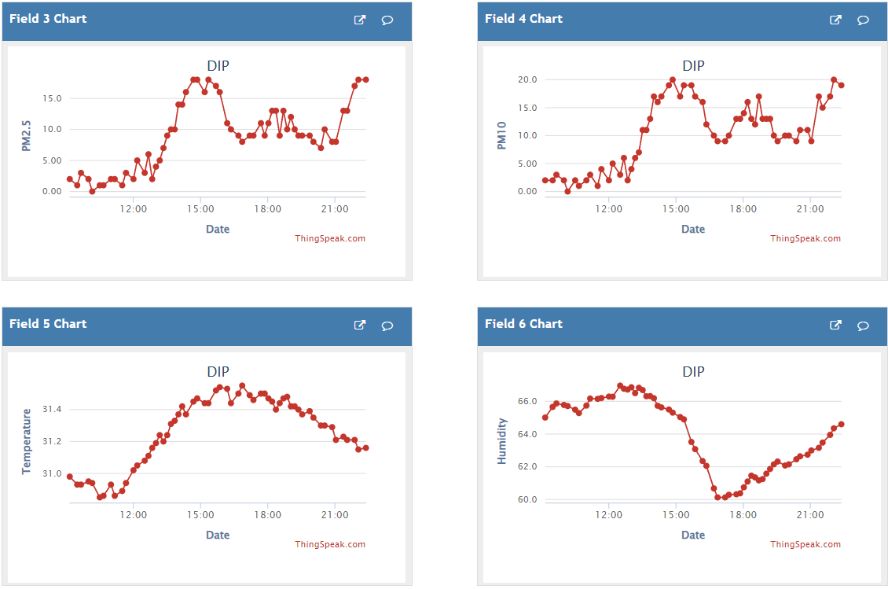

Figure - Field Data for Sound, PM2.5, PM10, Temperature & Humidity

### MATLAB Analysis & Visualisations

Data visualisation in ThingSpeak helps convert raw data into graphs, charts, and maps, making it easier to identify trends and patterns.

The MATLAB Analysis application integrated in ThingSpeak allows users to prepare, filter, and analyse data, such as calculating averages or performing predictive analysis. It also provides code templates for basic operations as well as in-built predictive models on live or historical data. Additionally, with the MATLAB Visualisations application, users can compare different datasets or display statistical distributions in easy-to-read graphs.

Predictive analysis and forecasting of environmental noise and dust levels help individuals and communities plan, allowing for preventive measures to reduce health impacts.

### Predicting Sound (dB) Levels

Using the MATLAB Analysis application in ThingSpeak, we have decided to use autoregressive modelling for predicting noise levels. Autoregression (AR) is a time series model where the current value is expressed as a linear combination of its past values. One of the key reasons as to why we used this model is that it is more effective for short-term forecasting.

The AR model is ideal for real-time applications like ThingSpeak, where data is continuously being collected and immediate predictions are performed. Its fast computational output makes it a suitable fit for IoT-based environmental monitoring systems, where processing speed is crucial as opposed to more complex models such as neural networks. Here is a breakdown of the steps involved in the code:

The code begins by drawing noise level data from a specific ThingSpeak channel, which is connected to a sensor through an ESP8266. The channelID and fieldID parameters identify the data source, while numPoints specifies the amount of data to fetch. The function thingSpeakRead fetches the data in a structured table format for data analysis.

Since ThingSpeak timestamps are recorded in UTC, they need to be converted to the local time zone (GMT+8) to ensure the data is aligned correctly with the local time of the noise measurements. This conversion is done using the datetime function, which first interprets the data in UTC and then adjusts it to the desired time zone.

Before modelling, the data is cleaned to remove any invalid entries, such as missing NaN (Not-a-Number) or infinite values, which can affect data predictive analysis. The infinite function is used to filter out the valid data points, ensuring that only reliable data is used in the analysis.

To improve the performance of the AR model, the data is split into a train and test set: training (80%) and testing (20%). The training set is used to fit the AR model, while the test set is used for evaluating its performance on unseen data.

The AR model is built by regressing the current noise levels against their previous values. An AR(4) model is used, meaning the noise levels are predicted based on the previous four values. The AR model's order, determined by arOrder, specifies how many past data points are considered for making predictions. The coefficients of the model are then estimated through linear regression.

Once the model is fitted with the training data, it is used to predict the noise levels in the test set. The predicted values are compared to the actual noise levels to assess the model's accuracy. The performance of the model is evaluated using the Mean Absolute Percentage Error (MAPE). MAPE is a common metric for time series models, measuring the average percentage error between the predicted and actual values. A small epsilon value is added to avoid division by zero errors. The smaller the MAPE score, the higher the model's accuracy.

After testing, the model is used to predict future noise levels. The AR model makes these forecasts by iteratively using the most recent observed values to predict the next set of points. The number of future points to predict is specified by numFuturePoints.

The historical data and predicted future noise levels are plotted together. This visualisation gives a clear picture of how the model’s predictions align with the actual past values, as well as how the noise levels are expected to behave moving forward.

The code output consistently provides a range of MAPE score of 5 to 20%, suggesting that the predicted values are relatively close to values seen in the test set, which is a good sign.

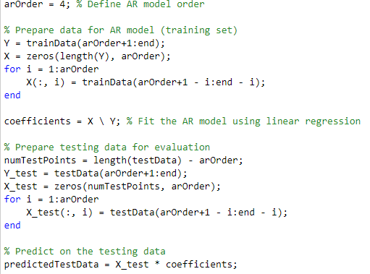

Figure - MATLAB code for Autogressive Model

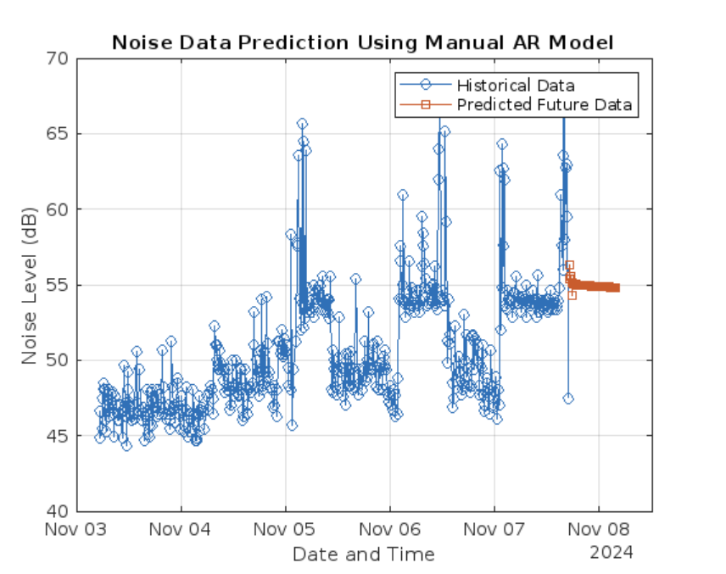

Figure - Predicted Sound Data Trend

### Predicting PM2.5 and PM10 Levels

Similarly for the prediction of PM2.5 and PM10 levels, we have used Autoregressive-Exogenous (ARX) modelling as opposed to the AR model used to predict noise levels. The ARX model is a modified version of the autoregression model as it incorporates external inputs that influence the system in addition to the past values of the time series. As previously mentioned, we have concluded that humidity and temperature affect environmental dust levels in the air based on the study made. Therefore, this model is ideal as it can efficiently handle more than one input, making it more accurate in scenarios where external factors can affect the overall output.

The process begins by extracting PM2.5, PM10, temperature, and humidity data from ThingSpeak. The thingSpeakRead function retrieves the data from the designated channel and is fetched in a structured table format for data analysis. The humidity data, as retrieved from ThingSpeak, is stored as a string which is not suitable for data analysis. Hence, the string values need to be converted into a numerical format. This is done by using the cellfun function in combination with a regular expression (regexp) to extract the numeric part from the string and convert it to a number using str2double.

Similarly with the predictive analysis for environmental noise, the data is cleaned of any missing or invalid values to ensure only valid data points are used for reliable and accurate predictions. Additionally, the data is split into a 80% and 20% train test set so that the model is tested on data it has not seen before, allowing for a reliable and accurate predictive analysis.

The ARX model consists of an autoregressive component (na) and exogenous inputs (nb) for temperature and humidity. The model’s order is set by the parameters na, nb, and nk, where na defines the number of past PM2.5 values considered, and nb specifies the number of past values of temperature and humidity used in the model. The ARX function then fits the model to the training data using linear regression to estimate the model coefficients.

The trained ARX model is tested against the testing dataset to evaluate its accuracy. The predicted PM2.5 values are compared to the actual values in the test set using the Mean Absolute Percentage Error (MAPE) metric.

After evaluating the model on historical data, we forecast future PM2.5 levels by predicting 150 future data points based on trends in temperature and humidity. The future values for temperature and humidity are linearly increased to simulate changing environmental conditions, and the ARX model uses these inputs to predict PM2.5 levels.

Both the historical and predicted PM2.5 data are plotted together, where historical data shows the actual recorded PM2.5 levels, while predicted values provide forecasting into future PM2.5 trends.

The predictive analysis for PM10 (Appendix) is conducted in the same way as PM2.5 analysis, with both using the ARX model, which takes historical values of the target variable (PM10 or PM2.5) and external inputs (temperature and humidity) to predict future values.

The ARX models consistently achieve MAPE scores ranging from 5% to 20%, indicating a relatively accurate prediction of both PM2.5 and PM10 levels based on the test data.

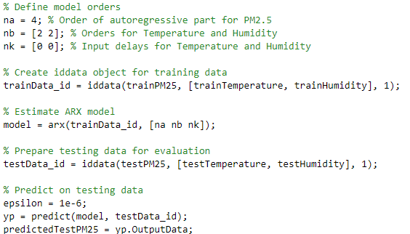

Figure - MATLAB code for ARX Model

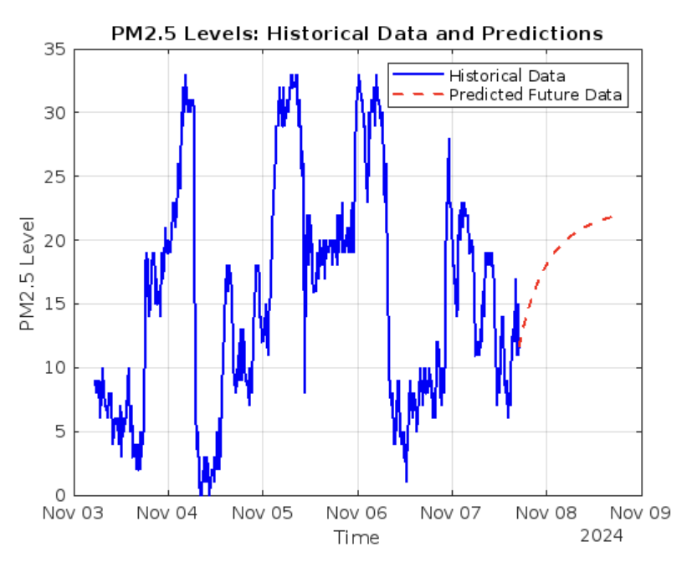

Figure - Predicted PM2.5 Data Trend

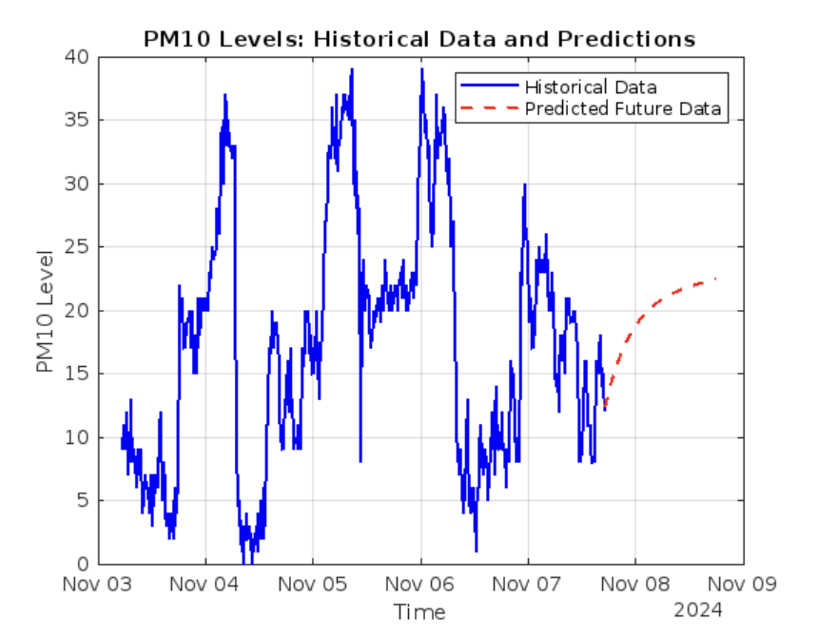

Figure - Predicted PM10 Data Trend

### Average Predicted Values

The system forecasts future noise levels based on historical data trends, providing an average predicted value that is uploaded to ThingSpeak for visualisation and easy data extraction by applications such as Telebot.

The predictive analysis process is the same as the analysis used for plotting data trends for predicted noise levels mentioned above.

Following model training, the system predicts and stores these future predicted values in an array called predictedValues. To provide a simplified forecast that reflects the general trend, the code calculates the mean of these predicted values, resulting in a single average value. This average forecast provides a clear, accessible insight into expected noise levels over the next period.

The thingSpeakWrite function is then used to upload this calculated average to a designated ThingSpeak channel, in this case Field 3 of channel 2660664. By storing the forecasted average on the ThingSpeak platform, the system makes the data easily accessible for external applications. Telebot can then retrieve this averaged prediction and share it with users, allowing them to easily monitor expected noise levels in real time.

This process is set to run on a recurring basis using ThingSpeak’s TimeControl application. TimeControl enables automatic execution of the predictive code at predefined intervals, ensuring the system continues to update the average forecast without requiring manual input. Each scheduled execution recalculates and updates the average predicted noise level on ThingSpeak, providing users with up-to-date insights and supporting real-time monitoring.

By automating this, the system continuously generates and uploads noise level forecasts, allowing users to benefit from consistent, timely updates with minimal oversight.

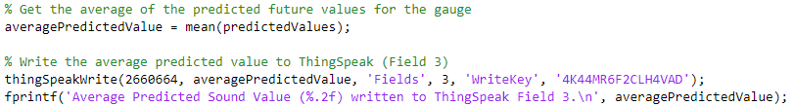

Figure - MATLAB code for Mean & thingSpeakWrite Function

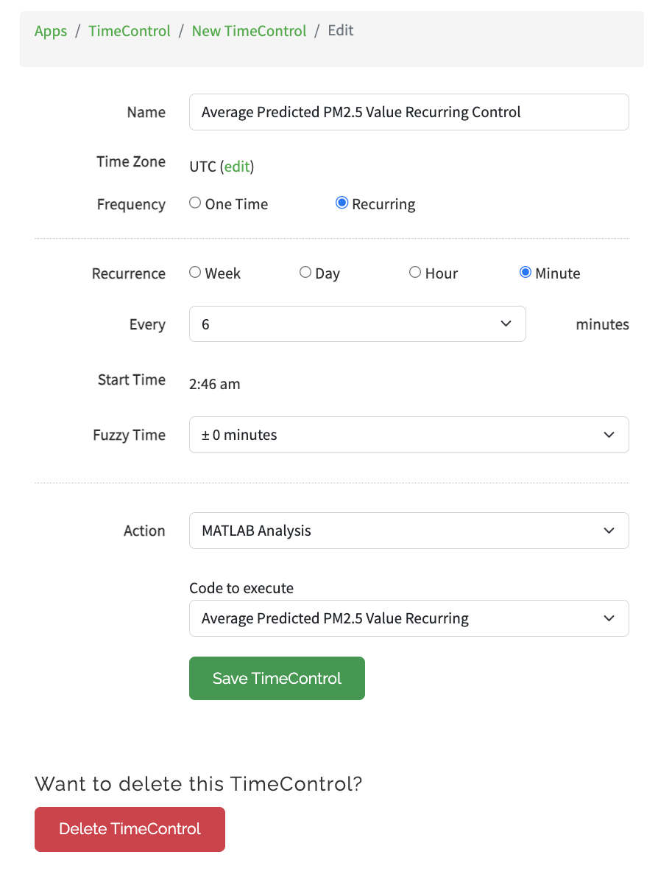

Figure - TimeControl Settings

### Visualisation Gauges

Visualisation gauges help provide a real-time display of current levels of noise (dB), PM2.5, and PM10. These gauges make it easy and provide an intuitive way for users to interpret and monitor the current as well as average predicted environmental conditions by using colour-coded segments that represent different threshold levels. The gauges are designed to visually represent the healthiness of the environment, from safe to hazardous levels. Here is the breakdown of the code:

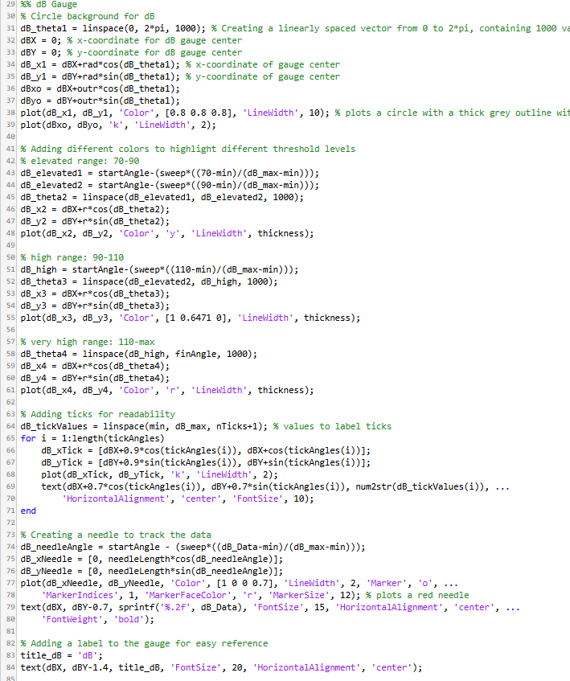

Figure - Parameter Code for Current Gauges for Sound, PM2.5 & PM10

Each gauge pulls its respective data from a ThingSpeak channel, such as sound, PM2.5 and PM10 respectively. The gauges are divided into different colour-coded segments, such as yellow for moderate, orange for slightly elevated and red for hazardous, which represent various ranges of environmental health thresholds as mentioned above. The colour thresholds are defined within the code to highlight these ranges.

Each gauge uses a circular design which is drawn using parametric equations to represent the current and full range of noise, PM2.5, or PM10 values. A "needle" is plotted on the gauge to indicate the current value. The angle of the needle is calculated based on the current data, and it is dynamically updated as new data is received.

The gauges include tick marks that correspond to significant values (for example: 60 dB, 75 dB) to help the user easily understand the current value. This includes a label in large font, such as "dB" or "PM2.5", to show what is being measured.

The code arranges the gauges for dB, PM2.5, and PM10 in a clear and organised layout within the figure window. Each gauge is drawn with a different range, but they all share a similar design and structure, ensuring uniformity across the visualisations.

In addition to displaying current real-time data for noise (dB), PM2.5, and PM10 levels, we have also incorporated predictive modelling to forecast future values to provide insight into potential trends. (Appendix C) These predicted values are then averaged and presented on dedicated gauges to allow users to view expected future values.

The prediction analysis for noise levels is conducted using the same autoregressive (AR) model as well as the same Autoregressive with Exogenous Inputs (ARX) model for PM2.5 and PM10, as used above in the MATLAB Analysis. After performing predictive modelling, the system calculates the average predicted values for each parameter-noise (dB), PM2.5, and PM10. This average is derived from a series of future predicted values generated by the AR or ARX models using the mean function in MATLAB.

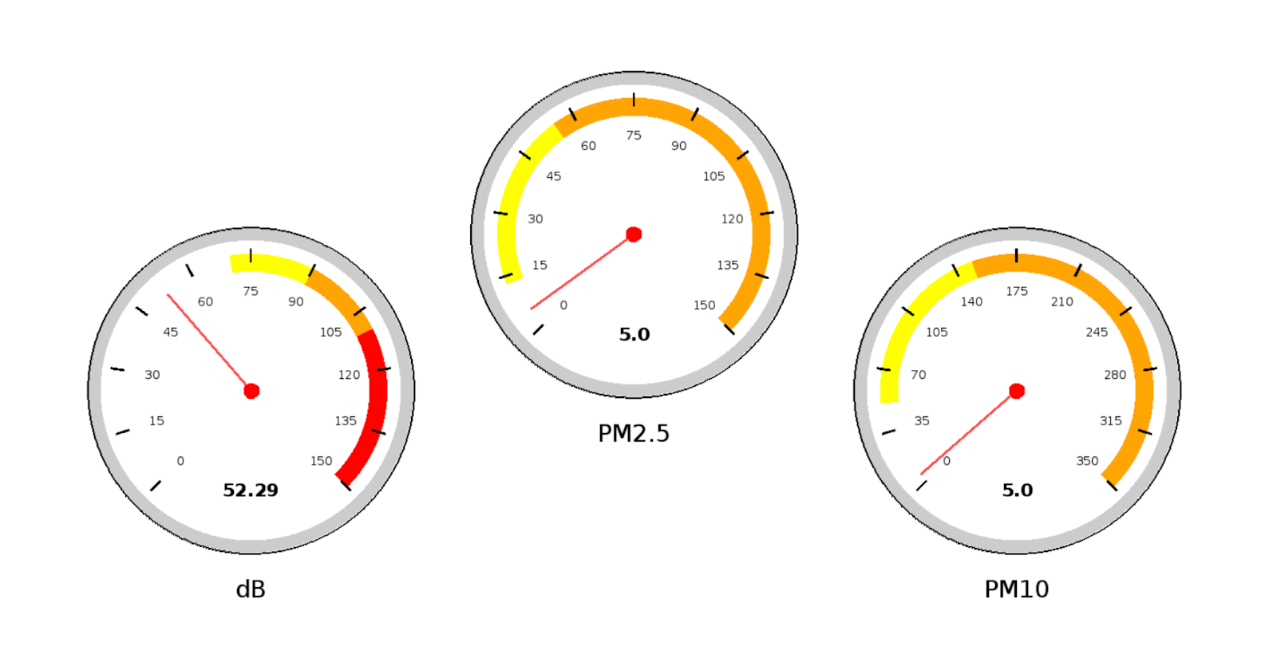

Figure - Current Gauges for Sound, PM2.5 & PM10

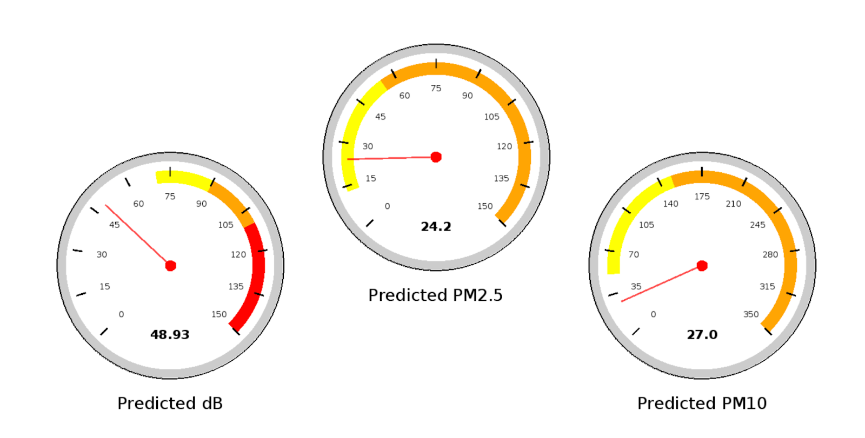

Figure - Average Predicted Gauges for Sound, PM2.5 & PM10

## Software: Telegram Bot

We have utilised Telebot, a Telegram Bot Application Programming Interface (API), to provide an intuitive and user-friendly interface for users to monitor environmental noise and dust levels. The Telebot provides an interface of the system’s data for the user, enabling real-time alerts, status updates, and easy access to current and predicted environmental data as well as data trends.



Figure - Telegram Logo

### Functionality of Telebot

We designed the Telebot to directly extract data from the sensors connected to the microcontroller, gathering data on noise levels (dB), particulate matter (PM2.5 and PM10), temperature, and humidity. This data is integrated and transmitted to ThingSpeak IoT platform for data analysis and visualisation. The bot allows users to retrieve real-time and predicted data.

Users can request the current environmental readings by sending the command /Current. The Telebot responds with real-time sensor data, including noise levels, PM2.5, PM10, temperature, and humidity, compiled in a single text message. Similarly, by entering the command /Predicted, users can access the forecasted values generated by the machine learning models in ThingSpeak. These predicted values help users anticipate potential health risks related to noise and air quality.

The Telebot is programmed with an alert system to check for hazardous levels at regular intervals and send alerts when dangerous levels are detected. For example, if noise levels exceed elevated levels or if PM2.5 and PM10 values reach harmful thresholds, the Telebot will immediately notify the user with specific guidance on exposure limits and protective measures. Additionally, the Telebot also provides warnings based on predicted values, allowing users to take preventive action. The bot is implemented with a delay between consecutive alerts to ensure users are not overwhelmed by frequent notifications.

To add on, Telebot provides quick access to data visualisations created on ThingSpeak. When users request current or predicted values, the Telebot includes a URL link to ThingSpeak visualisations, such as gauges and trend graphs, which display the data in an easily interpretable format. This feature enhances the user experience by offering a visual representation of the data alongside text-based updates.

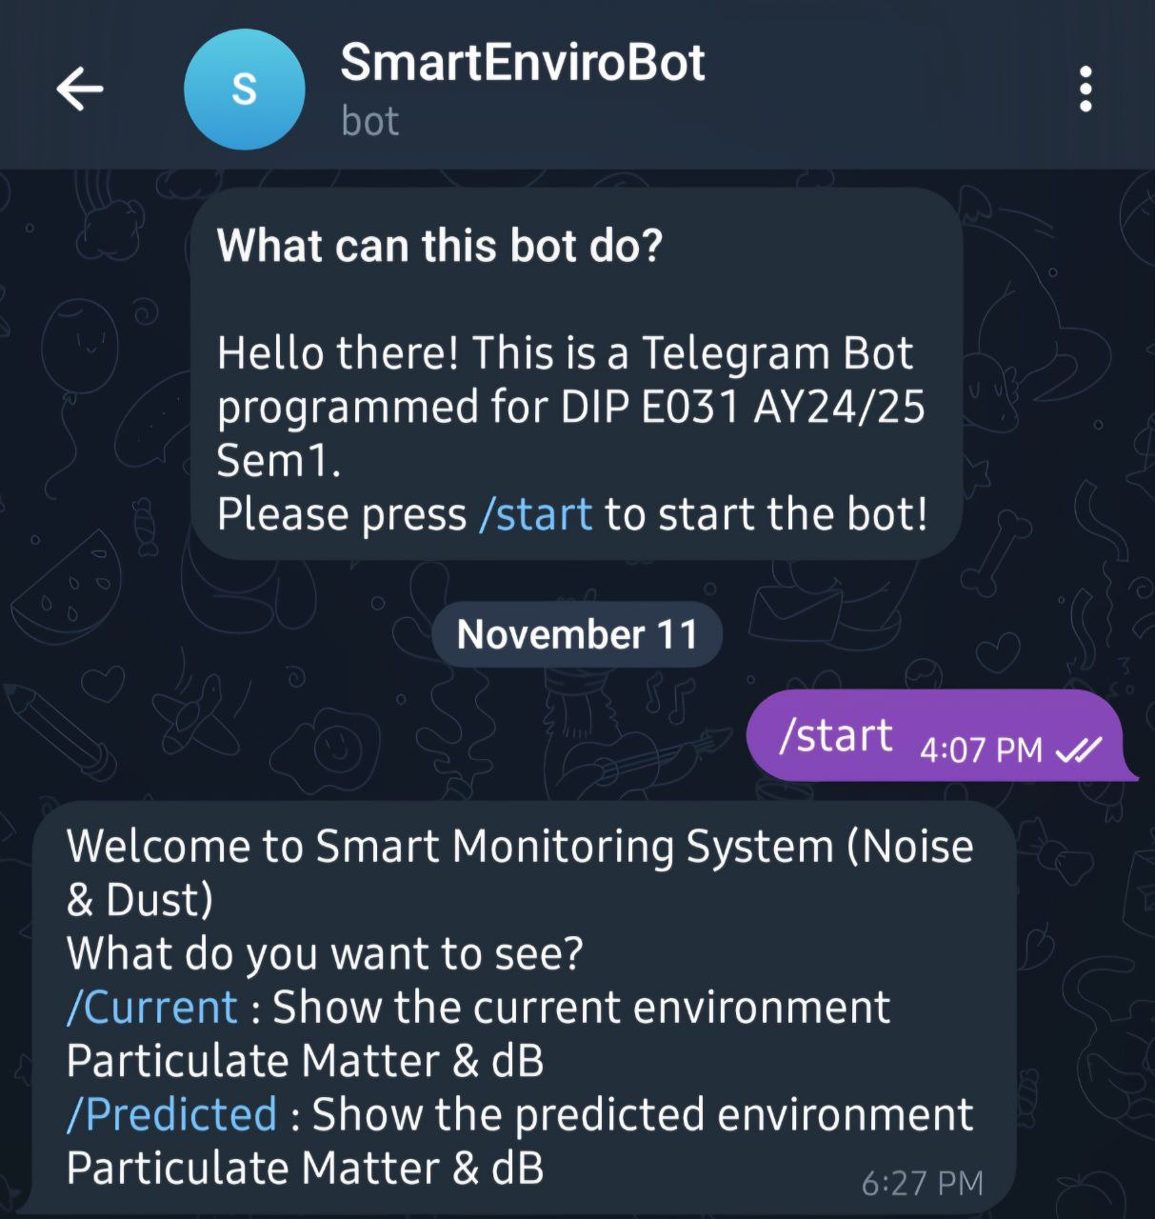

Figure - TeleBot Starting Prompt

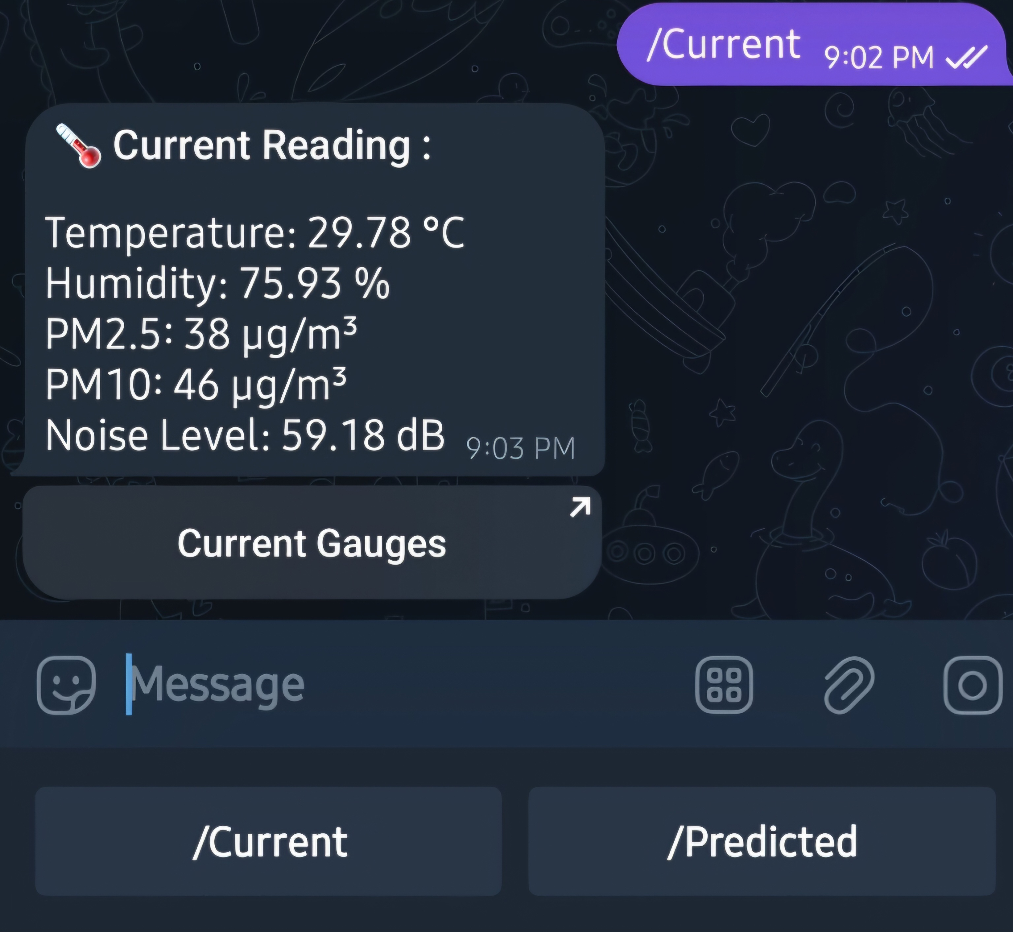 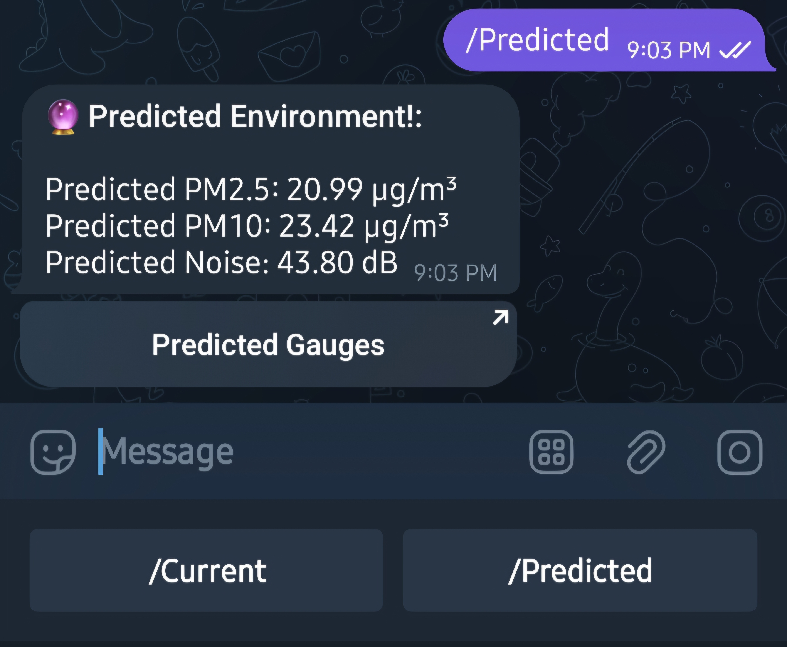

Figure - TeleBot providing Current and Predicted Readings

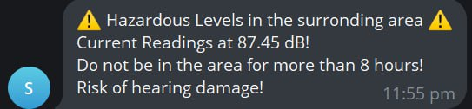

Figure - TeleBot Warning Message

### TeleBot Code Structure

The bot gathers real-time data from sensors using functions such as readdBSensor(), readPMSSensor(), and readTempHumdSensor(). These functions retrieve values from the sensors connected to the microcontroller, updating the data that the Telebot will share with the user.

“/Current” and “/Predicted” commands which include sendCurrentValuesToUser() and sendPredictedValuesToUser() help trigger specific functions that compile the relevant data into a formatted message and send it to the user. An introductory /start command displays all available commands with a custom keyboard for easy navigation for the user.

The bot continuously monitors both current and predicted values to detect hazardous conditions. hazardCurrentValues() and hazardPredictedValues() functions create and send hazard alerts when thresholds are exceeded, using predefined messages made for each level of severity.

The bot operates on intervals set by timers, ensuring it checks for new messages, updates data, and monitors hazard levels regularly. For example, the bot checks for new messages every second and updates data every 10 minutes to maintain accurate, up-to-date information.

# Schedule

|  |  |  |  |  |  |  |  |  |  |  |  |  |  |
| --- | --- | --- | --- | --- | --- | --- | --- | --- | --- | --- | --- | --- | --- |
| **Planning/Week** | 1 | 2 | 3 | 4 | 5 | 6 | 7 | 8 | 9 | 10 | 11 | 12 | 13 |
| Research on Microcontroller & Sensors |  |  |  | ✔ |  |  |  |  |  |  |  |  |  |
| Project Charter |  |  |  | ✔ |  |  |  |  |  |  |  |  |  |
| Purchasing of Parts |  |  |  |  | ✔ |  |  |  |  |  |  |  |  |
| **Implementation/Development** |  | | | | | | | | | | | | |
| Assemble and integrate the ESP8266 microcontroller with sensors |  |  |  |  |  |  | ✔ |  |  |  |  |  |  |
| Sensor and Firmware Calibration |  |  |  |  |  |  |  |  | ✔ |  |  |  |  |
| Circuit and Power Management |  |  |  |  |  |  |  |  | ✔ |  |  |  |  |
| Set up IoT platform (ThingSpeak) and enable Data Transmission |  |  |  |  |  |  |  |  | ✔ |  |  |  |  |
| Implement predictive analytics using MATLAB in ThingSpeak |  |  |  |  |  |  |  |  |  | ✔ |  |  |  |
| Create Visualisation Tool Gauges and Plotted Graphs |  |  |  |  |  |  |  |  |  |  | ✔ |  |  |
| Develop user interface (TeleBot) for data visualisation and alerting notifications |  |  |  |  |  |  |  |  |  |  |  | ✔ |  |
| Integration of all units and Housing Component |  |  |  |  |  |  |  |  |  |  |  | ✔ |  |
| **Testing** |  | | | | | | | | | | | | |
| Demonstration and Evaluation of Prototype |  |  |  |  |  |  |  |  |  |  |  | ✔ |  |

|  |  |
| --- | --- |
|  | Everyone |
|  | Hardware Team |
|  | Software Team (Data Analysis) |
|  | Software Team (TeleBot) |
| ✔ | Denotes Actual Completion |

Table 12 - Project Gantt Chart

Our team followed a planned schedule to meet various project milestones. Most of them were completed in a timely manner, however, during the implementation and development phases, we encountered several challenges, particularly in hardware setup and data analysis.

The initial battery setup for the microcontroller provided insufficient voltage for the sensors, delivering only around 3.7V instead of the required 5V. To address this, we installed a converter to step up the voltage and ensure stable sensor operation. Since our team was new to IoT platforms, we faced a learning curve while configuring ThingSpeak. We had to make several adjustments and troubleshooting to the settings, coding scripts as well as data upload intervals. Furthermore, we encountered limitations with Arduino's capabilities, particularly in its inability to take screenshots. This prevented us from directly capturing visualisations like gauges and plotted graphs created from MATLAB for display on Telebot. Instead, we worked around this issue and created public URLs for ThingSpeak visualisations and provided links to users on Telegram. The users could then view current and predicted values in gauges and graphs through the URLs.

While most project milestones were achieved within the scheduled time frame, we encountered delays in the development phase due to hardware issues, ThingSpeak integration challenges and limitations of the ESP8266 microcontroller. Nonetheless, we adapted to these obstacles with alternative solutions, such as using a voltage converter, adjusting data upload intervals, and providing ThingSpeak URLs for data visualisation. Despite the long delivery times for some components including the PCB, the team worked collaboratively to ensure the project was completed on time.

# Cost

|  |  |  |
| --- | --- | --- |
| Phase | Planned Costs | Actual Costs |
| Planning Phase  (Week 1 – 4) | $0.00 | $0.00 |
| Execution Phase  (Week 5 – 11) | $200.00 | $188.86 |
| Closing Phase  (Week 12 – 13) | $0.00 | $26.80 |
| Project Total Costs | $200.00 | $215.66 |

|  |  |  |  |  |  |
| --- | --- | --- | --- | --- | --- |
| Item Description | | Quantity | Price | | Total Costs |
| **Microcontrollers** | | | | | |
| WiFi Module NodeMCU ESP 8266 V3 Type-C | | 1 | $8.80 | | $8.80 |
| **Sensors** | | | | | |
| Temperature Humidity Barometer Sensor BME280 3.3V to 5V | | 1 | $12.00 | | $12.00 |
| PM2.5 Dust Sensor PMS7003 | | 2 | $26.80 | | $53.60 |
| Gravity: Analog Sound Level Meter | | 1 | $61.40 | | $61.40 |
| **Power** | | | | | |
| DC-DC Step Up Boost Converter 2.5 – VOUT to 5 – 12V (1A) 5W | | 1 | $4.40 | | $4.40 |
| Solar Panel 6V 1W | | 2 | $10.00 | | $20.00 |
| Solar Charge Controller Module 6V 12V 2A | | 1 | $9.00 | | $9.00 |
| 3.7V Li-Po Lithium Polymer Battery | | 1 | $15.00 | | $15.00 |
| 3.7V Li-Po Lithium Polymer Battery Charging Module (Type-C) | | 1 | $7.60 | | $7.60 |
| **Others** | | | | | |
| Custom PCB | 5 | $4.77 | | $23.86 | |
| **Total Cost** | | $215.66 | | | |

# Project Outcomes

|  |  |
| --- | --- |
| Project Deliverables | Learning Outcomes |
| Assembly and integration of ESP8266 microcontroller with sensors | We were able to connect the ESP8266 with the sensors used with the help of the data sheets by manufacturer and online examples. |
| Circuit and Power Management | For power management, we have used two 6V 1W solar panels with the goal to make charging the 3.7V Li-Po battery faster, prolonging the lifetime of the system in absence of an external power supply. We chose this battery for its compact size, making it ideal for powering the ESP8266. Additionally, due to our dust sensor (PMS7003) requiring 5V we had to use a DC-DC step up module to increase voltage output of the battery to power the PMS7003. However, output power is more than the input power from the solar panels which will eventually cause the battery to deplete over time. The decrease in the voltage output of the battery will cause our sensors to malfunction over time. Therefore, an improvement made could be choosing a battery with a higher output voltage or getting a better solar panel unit. |
| ESP8266 microcontroller link to ThingSpeak IoT platform | The ESP8266 can communicate with the ThingSpeak Server through a library called “ThingSpeak” made by MathWorks. From the documentation, reading and writing to ThingSpeak can be done by functions from the library. |
| IoT data visualisation and analysis and implementation of predictive analysis using MATLAB on ThingSpeak | Data retrieved from the ESP8266 can be visualised effectively using the MATLAB Visualisations application on the ThingSpeak IoT platform. With options like charts, plots, and gauges, we can effectively monitor and verify that the microcontroller and sensors are consistently collecting data as well as observing trends briefly. The MATLAB Analysis application, on the other hand, enables us to apply machine learning models for predictive analysis of our data as well as checking for the accuracy of the models used.  With its extensive library of built-in functions, we can accomplish this task efficiently. |
| Telebot for data visualisation and alerting notifications | The Telebot API provides our system the ability to send/receive messages on Telegram. Initially, it was planned for the Telebot to send images of the (current or predicted) visualisation gauges upon user prompts. However, due to the limitations of Arduino’s libraries, this was not feasible. Therefore, we programmed the Telebot to send users the same information in text format, with the image of the visualisation gauges embedded as a link in the text message. Additionally, the Telebot automatically alerts users via text message if noise or dust levels approach hazardous levels. This feature completes the overall system and enables us to achieve our goal of a smart monitoring system. |

# Reflection

Throughout this project, our team encountered a range of challenges and gained valuable insights into engineering and project management. We faced a lot of troubleshooting, especially when it came to hardware integration and data transmission. Prior to this project, most of us did not have any experience working with IoT platforms, which indicated that we had to learn wireless communication, data analytics and cloud-based visualisation from the ground up. Setting up ThingSpeak, managing the data flow from sensors, and learning how to apply machine learning models for predictive analytics all required a lot of adaptation and independent learning.

One of the major challenges we encountered was the variability in data trends during environmental monitoring. At times, these fluctuations led to periods of instability, which impacted the accuracy of our predictive models. Moving forward, a useful improvement would be to explore techniques for managing these fluctuations, such as data smoothing or filtering methods. Additionally, experimenting with alternative machine learning models and potentially more advanced microcontrollers, like the Raspberry Pi, could offer better data processing capabilities and handle more complex algorithms with ease.

Designing and coding the data visualisation tools was also a challenging yet rewarding part of the project. Our goal was to transform raw data into meaningful, user-friendly insights, which required developing visual tools like gauges, trend graphs, and an interactive interface. This process wasn’t as straightforward as expected. Creating these visuals involved finding the right libraries, coding dynamic updates, and ensuring that each element was easy to interpret. This taught us how to display data in a way that would make it user friendly. A good data visualisation should not just display data but also highlight patterns and trends through the usage of plots or graphs that would allow users to make informed decisions, which is essential in environmental monitoring.

While the system can effectively monitor environmental conditions and alerts users as needed, it is unable to sustain and operate for long periods of operation. This issue mainly comes down to the solar panels we used. The system’s power usage eventually outpaces the power provided by the panels, leading the battery to drain over time. As the battery depletes, some sensors start to malfunction because they require a steady and consistent input voltage to function correctly. Once the battery level drops too low, it cannot supply the necessary voltage for the sensors, which affects their accuracy and operation. Upgrading to more efficient solar panels would be a big step toward making the system sustainable over long-term use.

Additionally, building a housing enclosure for the system using 3D printing could make it more durable and adaptable for different environments, ensuring that it is better protected and easier to deploy whenever needed.

The project also allowed us to apply a wide range of engineering principles, from circuit analysis for integrating sensors with voltage regulation, to using IoT communication and data analytics for real-time monitoring. It highlighted how engineering and technology can be leveraged to solve real-world problems, bringing together smart sensing, AI-driven forecasting, and user-focused design to improve environmental monitoring.

Looking ahead, we see many areas for potential development. Upgrading to a more powerful microcontroller would enhance the system’s scalability and enable it to handle more complex algorithms with greater flexibility. More advanced AI and machine learning models could allow for deeper analysis of the relationships between environmental parameters, potentially enabling earlier predictions of hazardous conditions. Improving power management is also essential for future iterations, allowing the system to operate sustainably in areas where solar power might be limited.

Overall, this project has provided us the opportunity to tackle real-world engineering challenges, allowing us to gain the hands-on experience that our curriculum does not normally provide. We are grateful for this opportunity to pick up new skills that are invaluable for future endeavours that we may embark on.

# Acknowledging/Declaring the Use of GAI

Please refer to NTU's Current Policy & Guidelines on the Use of Generative AI available in NTUlearn home page and the link:

<https://entuedu.sharepoint.com/sites/Student/dept/ctlp/SitePages/Exploring-the-Impact-of-Generative-Artificial-Intelligence-(GAI)-Tools-on-Education.aspx>

* Complete the following declaration if applicable.
* Create a Paper Trail to document the input prompt, output obtained, and how you have used it

I Muhammad Azfar Nasri Bin Azman (student name), E220197@e.ntu.edu.sg (NTU email), on behalf of my team E031, honestly and sincerely make the following declaration in relation to the following course submission:

1. Name of course: Design Innovative Project

2. Course Code: EE3180

3. Instructor: Associate Professor Chan Pak Kwong

4. Title of Assignment/Project Submission: Project Report - Smart Monitoring Electronic System for Environmental Noise and Dust

In relation to the foregoing I hereby declare that, fully and properly in accordance with the Assignment/Project Instructions I have (check where appropriate):

i. Used GAI as permitted to assist in generating key ideas only. ☐

ii. Used GAI as permitted to assist in generating a first text only. ☐

And/or

iii. Used GAI to refine syntax and grammar for correct language submission only. ☐

Or

iv. As it is not permitted: Not used GAI assistance in any way in the development or generation of this assignment or project.

I also declare that I have :

a. Fully and honestly submitted the digital paper trail required under the assignment/project instructions; and that

b. Wherever GAI assistance has been employed in the submission in word or paraphrase or inclusion of a significant idea or fact suggested by the GAI assistant, I have acknowledged this by a footnote; and that,

c. Apart from the foregoing notices, the submission is wholly my own work.

Muhammad Azfar Nasri Bin Azman 11/11/2024



Student Name & Signature Date

Team E031

1. Muhammad Azfar Nasri Bin Azman
2. Danial Ong
3. Darryl Tan Han Yu
4. Dylan Ser Zi Ler
5. Ignatius Chin Zheng Hao
6. Muhammad Saajud S/O Jiaudden
7. Geng Zhiwei
8. Bu Yizhe

# References

[1] ‘NodeMCU ESP8266 Specifications, Overview and Setting Up’. Accessed: Nov. 11, 2024. [Online]. Available: <https://www.make-it.ca/nodemcu-details-specifications/>

[2] I. Hübschmann, ‘Is the ESP8266 WiFi Module the Right Choice for You?’, Nabto. Accessed: Nov. 11, 2024. [Online]. Available: <https://www.nabto.com/is-esp8266-wifi-module-right-choice-for-you/>

[3] ‘Gravity__Analog_Sound_Level_Meter_SKU_SEN0232-DFRobot’. Accessed: Nov. 11, 2024. [Online]. Available: <https://wiki.dfrobot.com/Gravity__Analog_Sound_Level_Meter_SKU_SEN0232>

[4] ‘Temperature Barometer Sensor BMP280 - Default Title’, Kuriosity. Accessed: Nov. 11, 2024. [Online]. Available: <https://kuriosity.sg/products/temperatureebarometer-sensor-bmp280?variant=447572991347777>

[5] ‘ESP8266 with BME280 using Arduino IDE (Pressure, Temperature, Humidity) | Random Nerd Tutorials’. Accessed: Nov. 11, 2024. [Online]. Available: https://randomnerdtutorials.com/esp8266-bme280-arduino-ide/

[6] ‘PM2.5 Dust Sensor PMS7003’, Kuriosity. Accessed: Nov. 11, 2024. [Online]. Available: <https://kuriosity.sg/products/pm2-5-dust-sensor-pms7003>

[7] P. Zhou, "PMS7003 Series Data Manual," Plantower, Ver. 2.5, Jun. 2016. [Online]. Available: <https://www.espruino.com/datasheets/PMS7003.pdf>

[8] ‘3.7V~High Temperature Series - Zhongshun Xinneng’, ZONCELL. Accessed: Nov. 11, 2024. [Online]. Available: <https://www.zoncell.com/en/product/lp1s-t/>

[9] ‘3.7V Li-Po Lithium Polymer Battery 100mAh 600mAh 1200mAh 1600mAh 2000m’, Kuriosity. Accessed: Nov. 11, 2024. [Online]. Available: <https://kuriosity.sg/products/3-7v-li-po-lithium-polymer-battery-100mah-600mah-1200mah-1600mah-2000mah-5000mah>

[10] ‘DC-DC Step Up Boost Converter 2.5 - VOUT to 5 - 12V (1A) 5W’, Kuriosity. Accessed: Nov. 11, 2024. [Online]. Available: <https://kuriosity.sg/products/dc-dc-step-up-boost-converter-2-5-vout-to-5-12v-1a-5w>

[11] ‘Solar Panel 6V 1W’, Kuriosity. Accessed: Nov. 11, 2024. [Online]. Available: <https://kuriosity.sg/products/solar-panel-6v-1w>

[12] ‘Solar Charge Controller Module 6V 2A - Kuriosity’. Accessed: Nov. 11, 2024. [Online]. Available: <https://kuriosity.sg/products/solar-charge-controller-module-6v-2a?_pos=1&_psq=solar+contro&_ss=e&_v=1.0>

[13] ‘Altium Designer - PCB Design Software’. Accessed: Nov. 11, 2024. [Online]. Available: <https://www.altium.com/altium-designer>

[14] “What are the WHO Air quality guidelines?” World Health Organization, WHO, Sep. 22,2021. Accessed: Nov. 11, 2024. [Online]. Available: <https://www.who.int/news-room/feature-stories/detail/what-are-the-who-air-quality-guidelines>

[15] M. Mermiri et al., “Effect of PM2.5 levels on ED visits for respiratory causes in a Greek Semi-Urban area,” Journal of Personalized Medicine, vol. 12, no. 11, p. 1849, Nov. 2022, doi: 10.3390/jpm12111849.

[16] “Noise,” World Health Organization: WHO, Apr. 27, 2010. Accessed: Nov. 11, 2024. [Online]. Available: <https://www.who.int/europe/news-room/fact-sheets/item/noise>

[17] J. Xiao, X. Li, and Z. Zhang, “DALY-Based health risk assessment of construction noise in Beijing, China,” International Journal of Environmental Research and Public Health, vol. 13, no. 11, p. 1045, Oct. 2016, doi: 10.3390/ijerph13111045.

[18] N. Vaishali, G. Verma, and R. M. Das, “Influence of Temperature and Relative Humidity on PM2.5 Concentration over Delhi,” MAPAN, vol. 38, no. 3, pp. 759–769, May 2023, doi: 10.1007/s12647-023-00656-8.

[19] “Decibel chart: What you need to know,” NCOA Adviser, Nov. 06, 2024. Accessed: Nov. 11, 2024. [Online]. Available: <https://www.ncoa.org/adviser/hearing-aids/decibel-levels/#:~:text=Sound%20levels%20are%20most%20commonly,registers%20at%20around%2060%20decibels>

[20] "Infosheet on Noise Regulations and Guidelines in Singapore," OneService Singapore, 2022. Accessed: Nov. 11, 2024. [Online]. Available: <https://www.oneservice.gov.sg/docs/default-source/default-document-library/noise-infosheet.pdf>

[21] "Computation of the Pollutant Standards Index (PSI)" Singapore National Environmental Agency (NEA), 2014. Accessed: Nov. 11, 2024. [Online]. Available: <https://www.haze.gov.sg/docs/default-source/faq/computation-of-the-pollutant-standards-index-(psi).pdf>

[22] “Haze Air Quality - the National Environment Agency,” Singapore National Environmental Agency (NEA). Accessed: Nov. 11, 2024. [Online]. Available: <https://www.haze.gov.sg/>

# Appendix A – Members Contribution

|  |  |  |  |
| --- | --- | --- | --- |
|  | Name | Project contributions | Report Contribution |
| 1 | Muhammad Azfar Nasri Bin Azman | * Group Leader * Hardware Team: Hardware Research * Hardware Team: Hardware Connection, Testing and Troubleshooting * Hardware Team: ESP8266 / Arduino Programming   + Reading of Hardware Sensors   + Sensor Library   + ThingSpeak API   + Telegram Bot API   + Read and Write to ThingSpeak Server * Hardware Team: PCB Design   + Schematic Design   + 3D model and Tracing * Software Team (Telebot): Telegram Bot Code   + Read user commands & execute accordingly     - Current Values from Sensors     - Predicted Values from ThingSpeak   + Custom Keyboard   + Auto send Hazard Alerts     - Implement 10mins delay in alert interval * Purchasing of Hardware Items | * Project Summary * Hardware * Software: TeleBot * Reflection * Project Outcome * Appendix A * Appendix B * Appendix C (Telegram Code) * Acknowledgement |
| 2 | Danial Ong | * Treasurer * Hardware Team: Hardware Connection, Testing and Troubleshooting * Video Team: Crafting storyline, filming and editing of video submission | * Cost |
| 3 | Darryl Tan Han Yu | * Software Team (Data Analysis): Visualisation Gauge Tools * Software Team (Telebot): Telegram Bot Code * Software Team: Debugging | * Project Scope * Visualisation Gauges * Project Outcomes * Reflections * Software: Telebot * Appendix A-C |
| 4 | Dylan Ser Zi Ler | * Software Team (Data Analysis): Predictive Analysis for PM2.5 & PM10 * Software Team (Data Analysis): Data Visualisation Plotted Data Trends * Software Team (Data Analysis): Average Predicted Values & ThingSpeak Dashboard * Software Team: Debugging | * Project Group Blogs * Project Schedule * Environmental Noise and Dust * Predictive Analysis for PM2.5 and PM10 * Average Predictive Values * Software: Telebot * Reflections * Appendix A-C |
| 5 | Ignatius Chin Zheng Hao | * Software Team (Data Analysis): Predictive Analysis for Sound (dB) * Software Team (Data Analysis): Data Visualisation Gauge Tools * Software Team (Data Analysis): Data Visualisation Plotted Data Trends * Software Team (Telebot): Telegram Bot Code | * Project Purpose * Environmental Noise and Dust * Predictive Analysis for Sound (dB) * Project Outcomes * Software: Telebot * Reflections * Appendix A-C * Acknowledgements |
| 6 | Muhammad Saajud S/O Jiaudden |  |  |
| 7 | Geng Zhiwei |  |  |
| 8 | Bu Yizhe |  |  |

# Appendix B – General Information

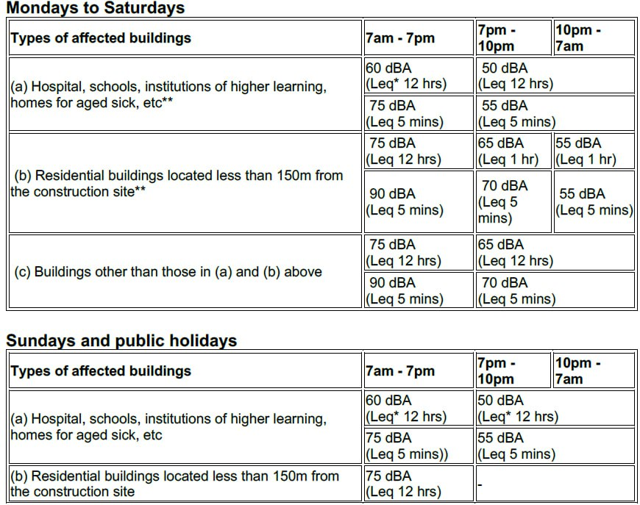

Figure - Noise Guidelines by NEA

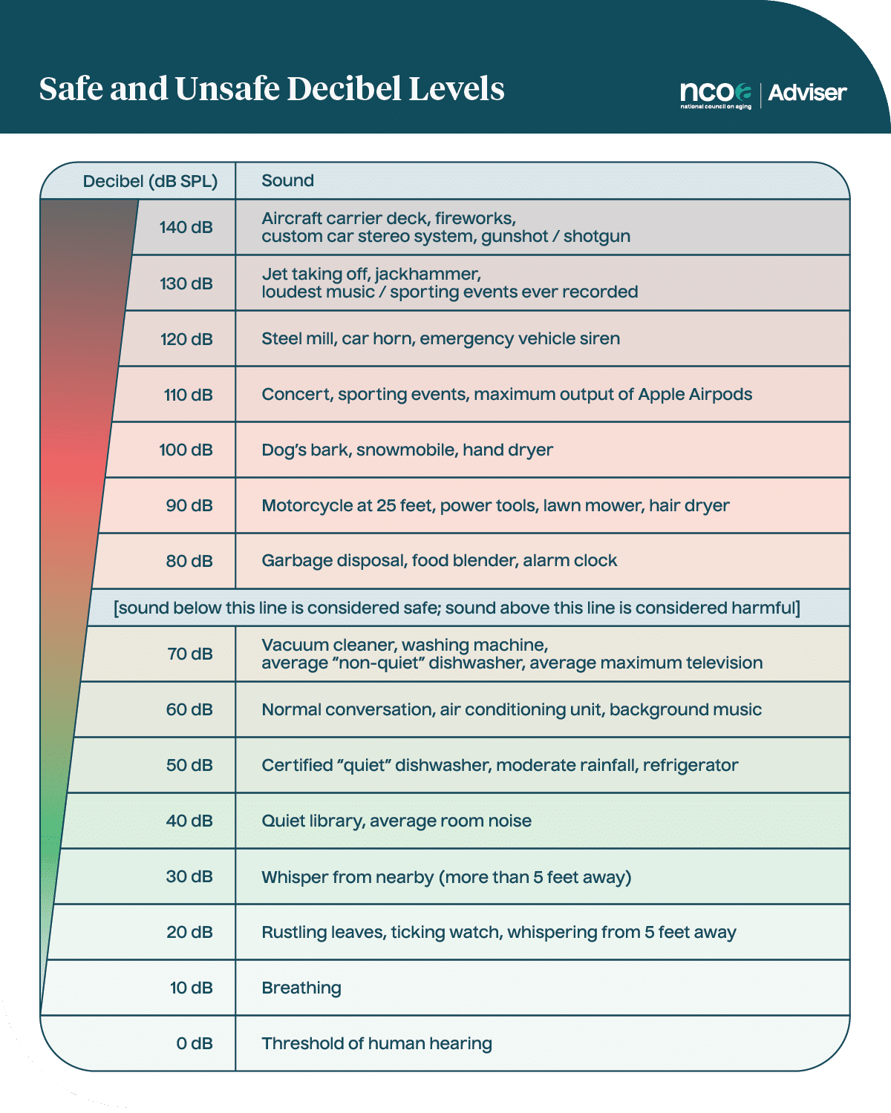

Figure - Guidelines for Noise Levels from National Council on Aging

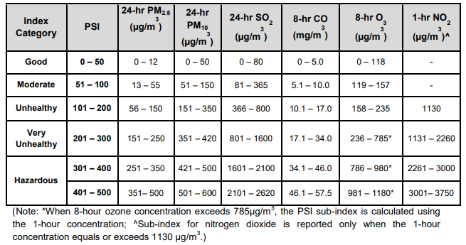

Figure - Air Quality Quantities by NEA

# Appendix C – MATLAB & Arduino Code

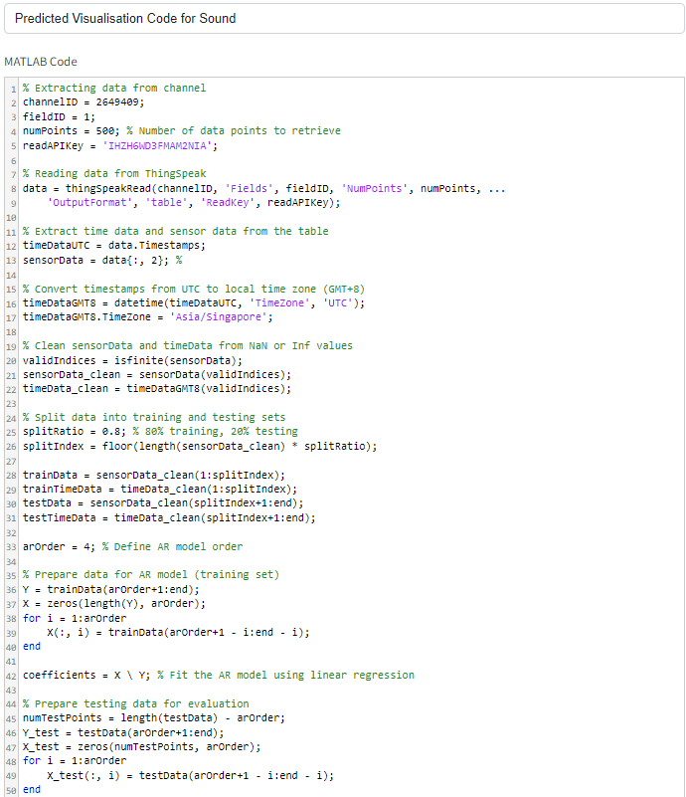

Figure - Code for Predict Sound Plotted Graph Part 1

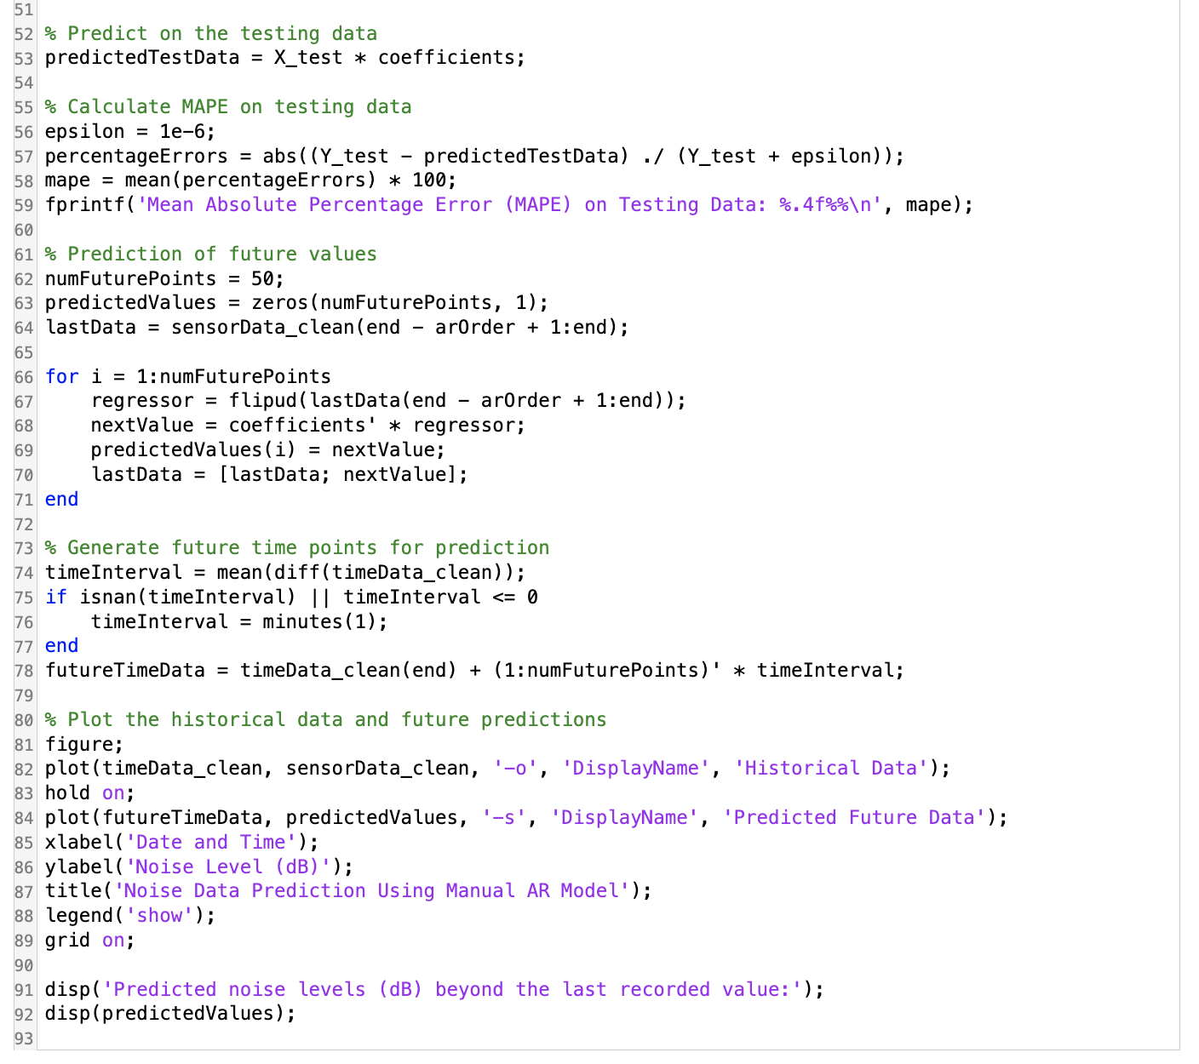

Figure - Code Predicted Sound Plotted Graph Part 2

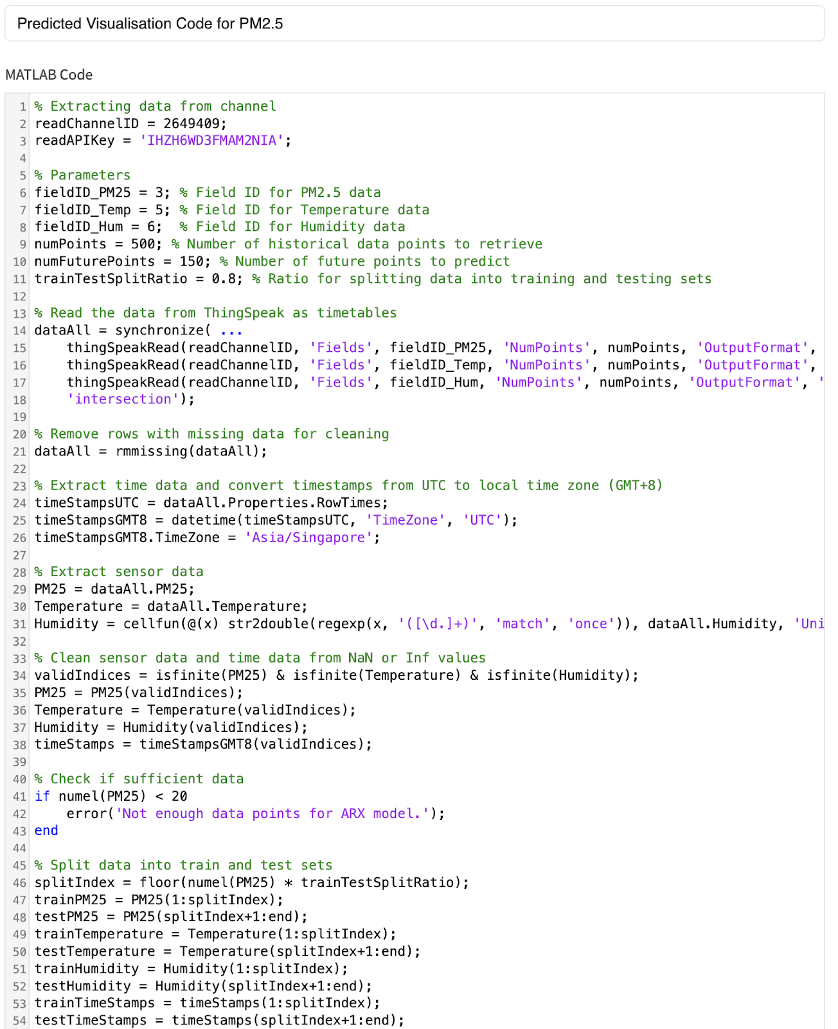

Figure - Code for Predicted PM2.5 Plotted Graph Part 1

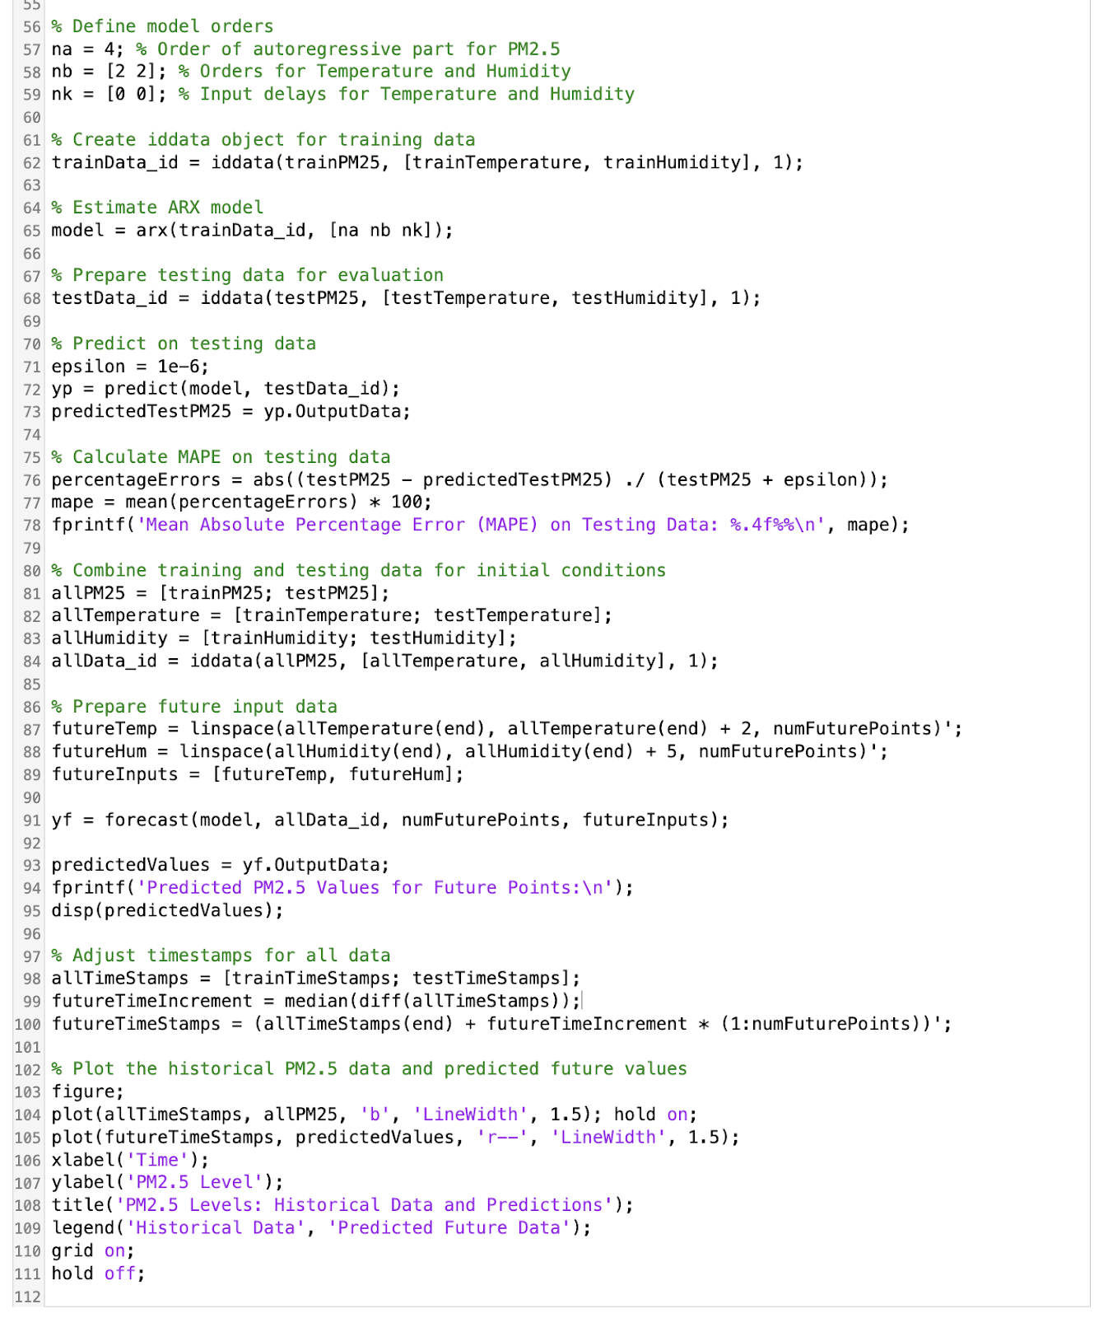

Figure - Code for Predicted PM2.5 Plotted Graph Part 2

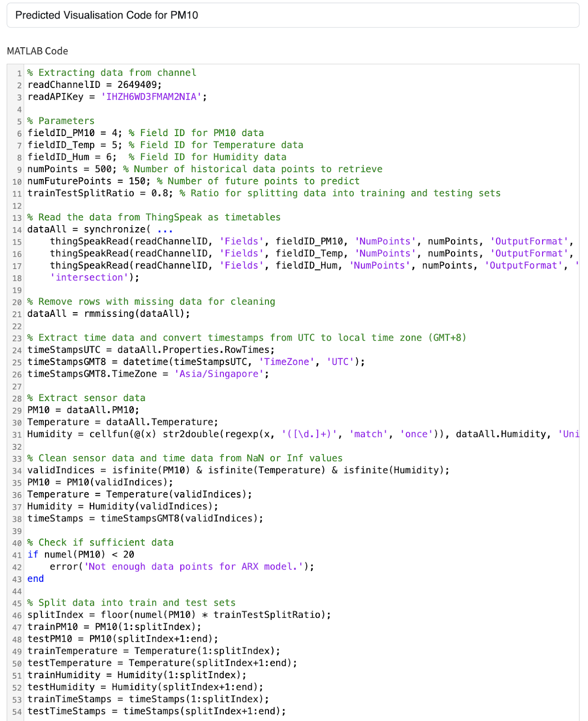

Figure - Code for Predicted PM10 Plotted Graph Part 1

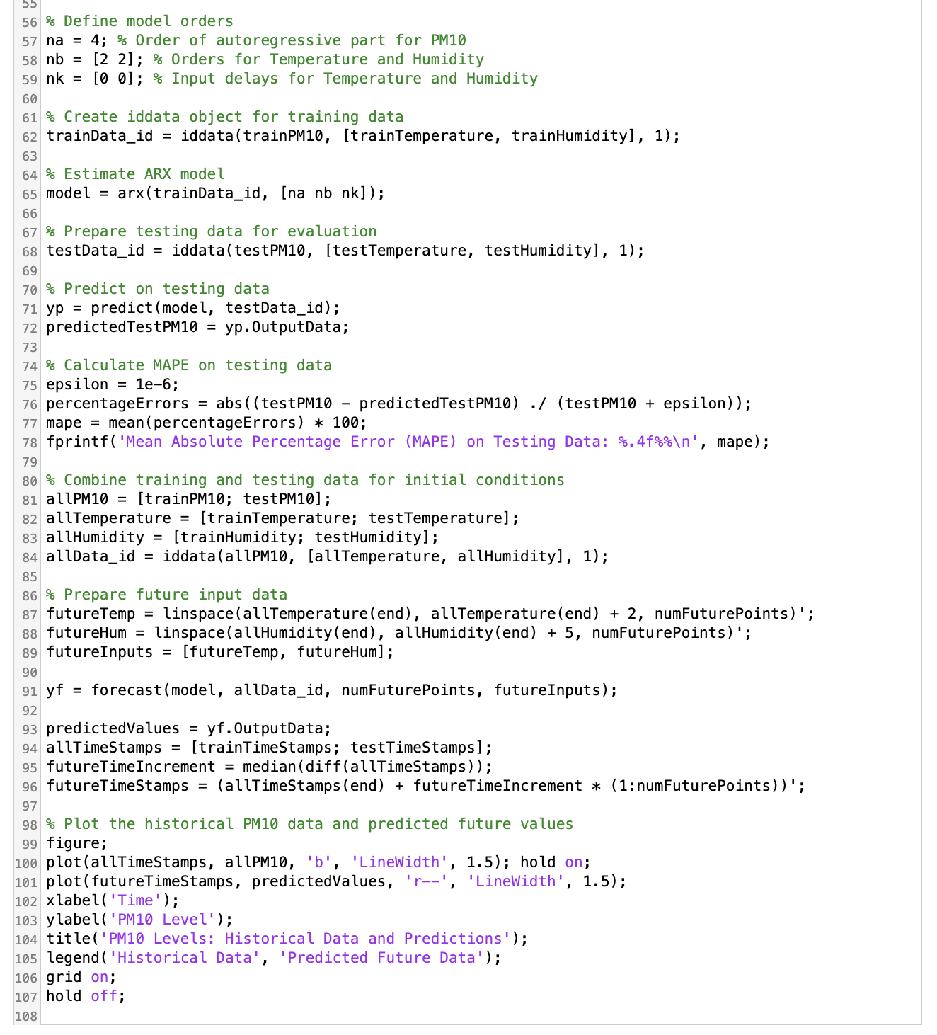

Figure - Code for Predicted PM10 Plotted Graph Part 2

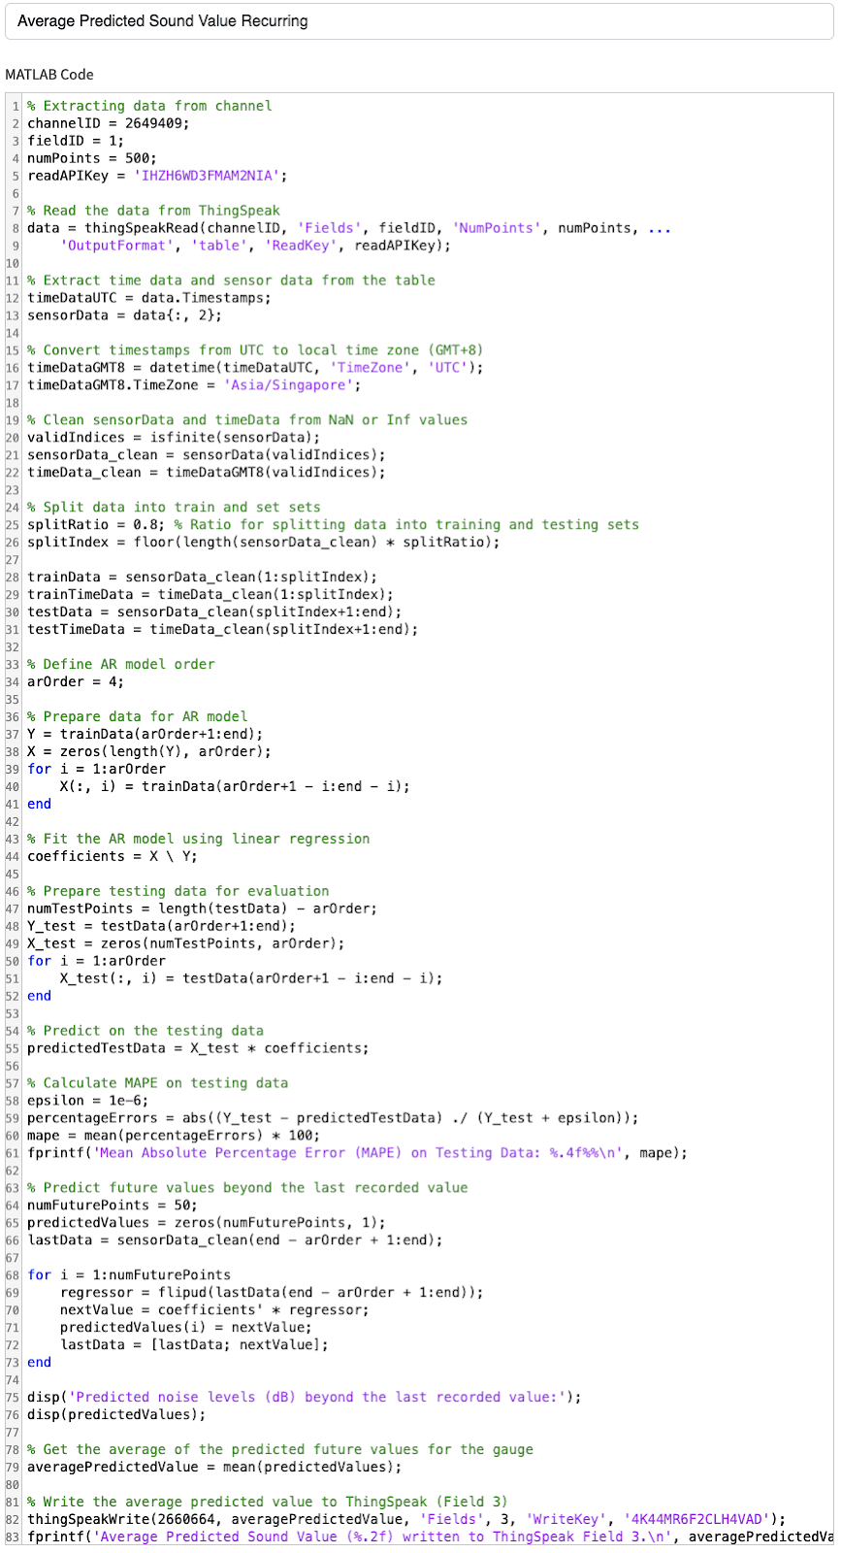

Figure - Code for Average Predicted Sound Values

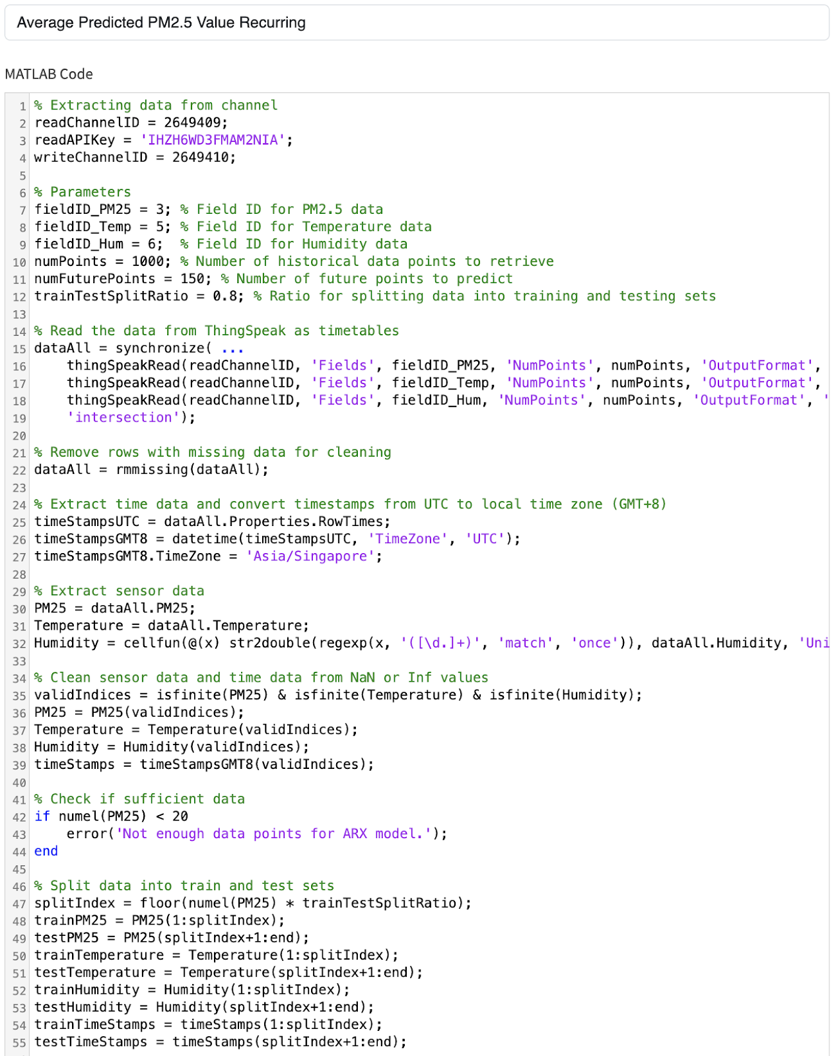

Figure - Code for Average Predicted PM2.5 Values Part 1

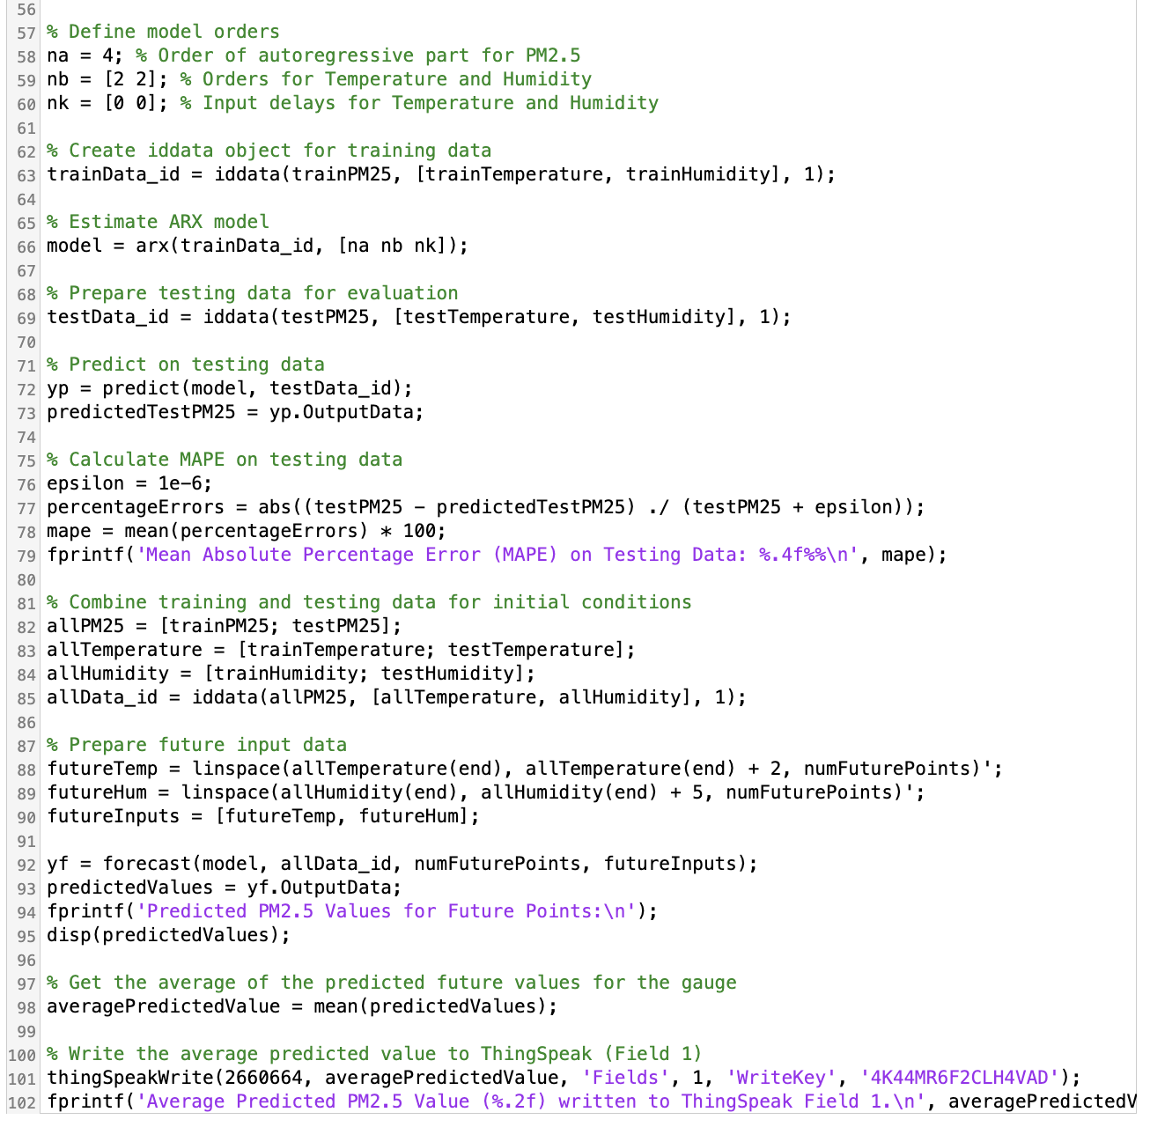

Figure - Code for Average Predicted PM2.5 Values Part 2

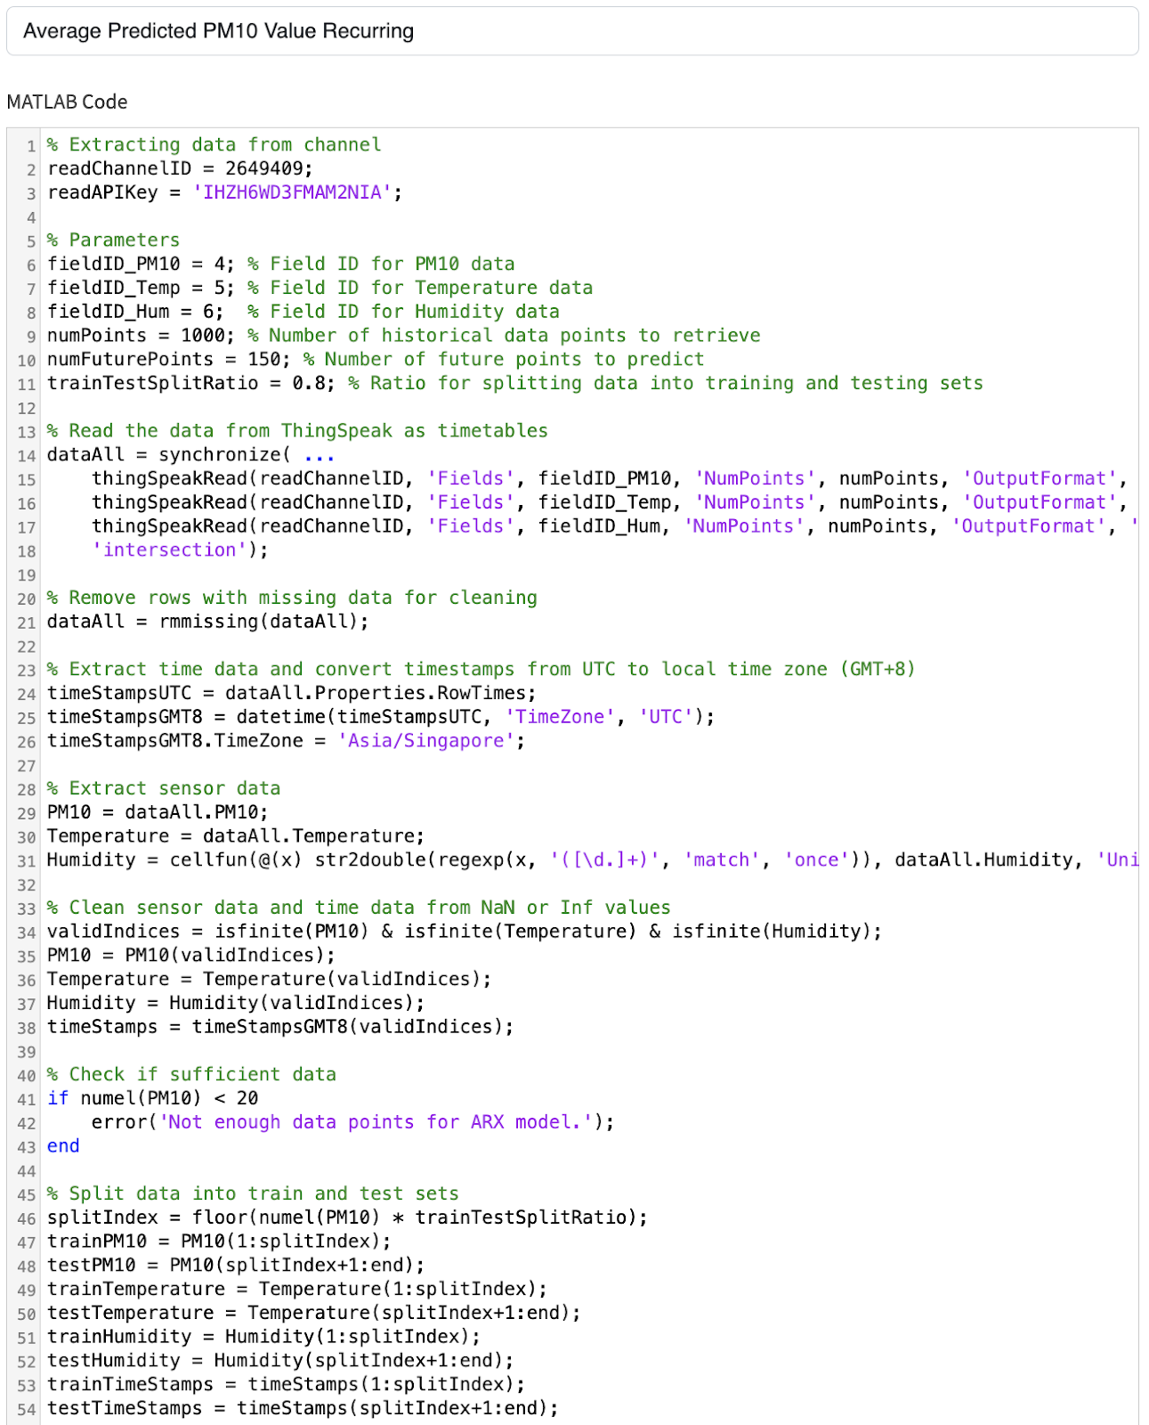

Figure - Code for Average Predicted PM10 Values Part 1

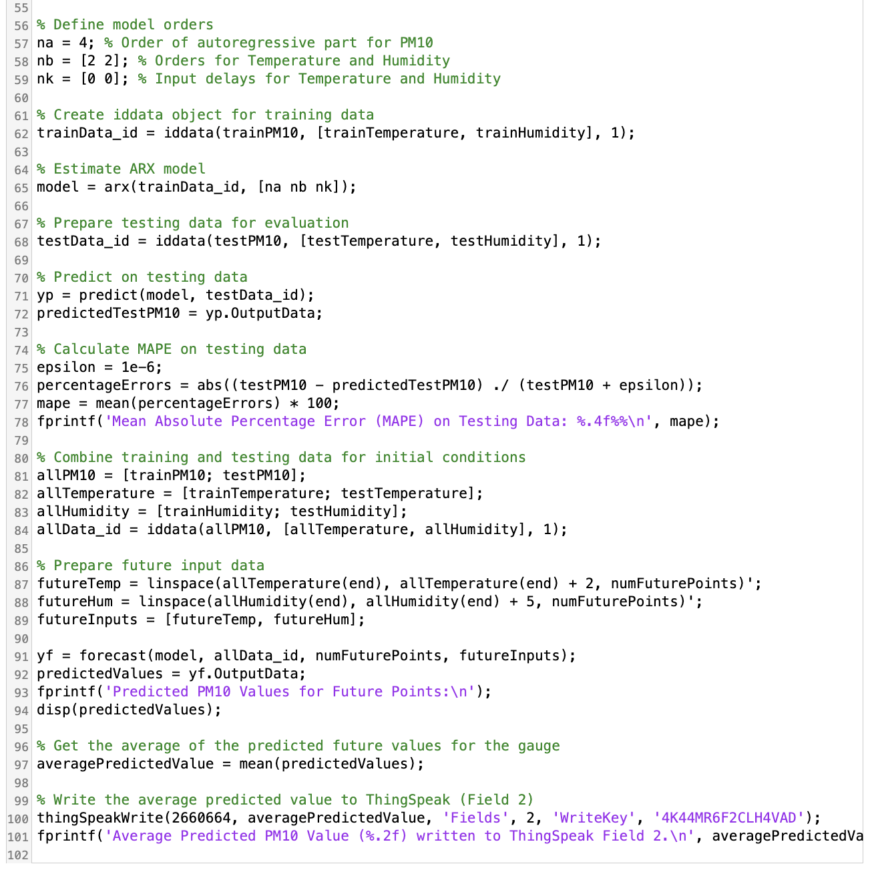

Figure - Code for Average Predicted PM10 Values

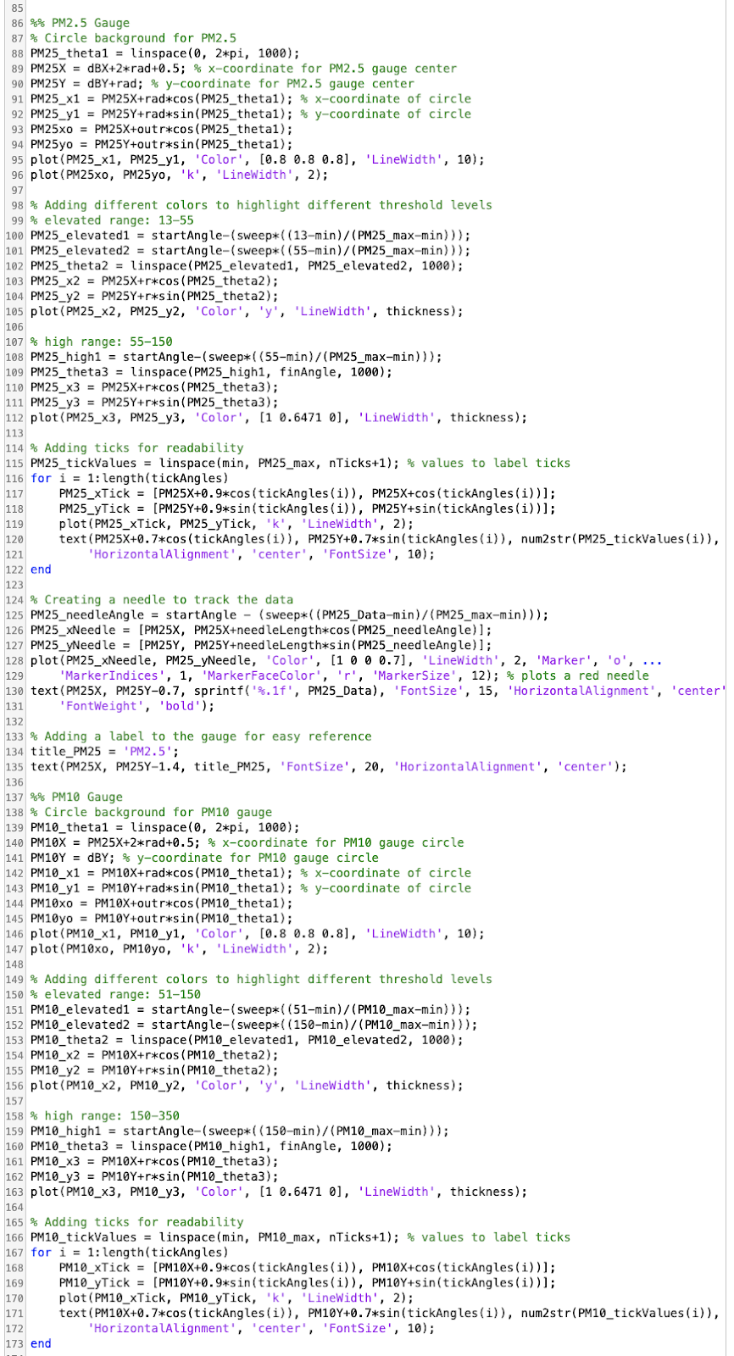

Figure - Code for Current Gauges for Sound, PM2.5 & PM10 Part 1  
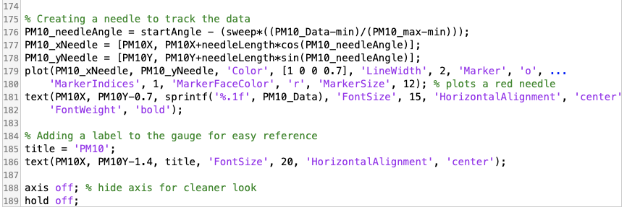

Figure - Code for Current Gauges for Sound, PM2.5 & PM10 Part 2

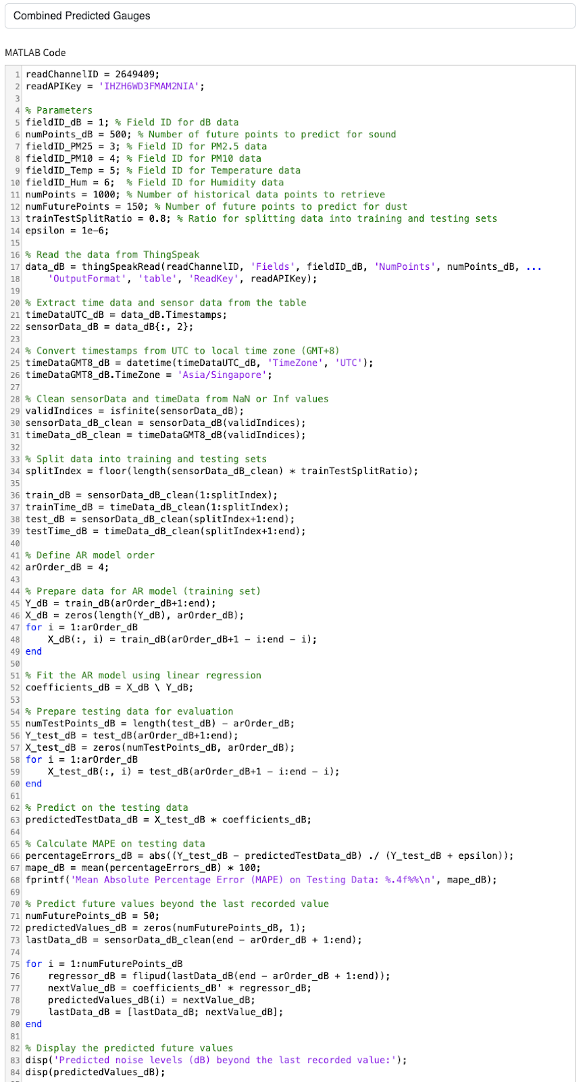

Figure - Code for Average Predicted Value Gauges for Sound, PM2.5 &PM10 Part 1

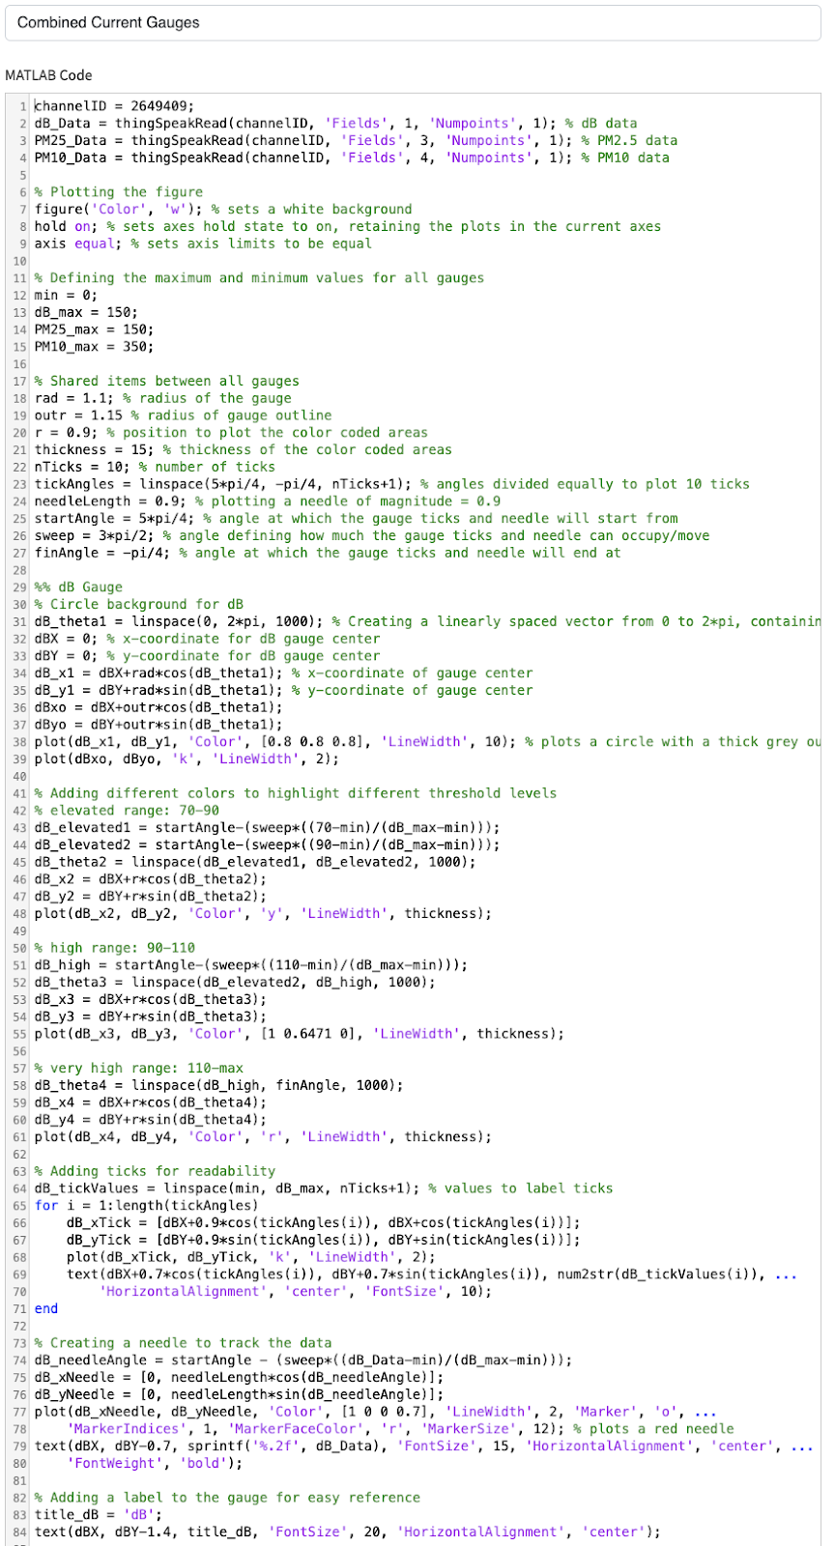

Figure - Code for Average Predicted Value Gauges for Sound, PM2.5 &PM10 Part 2

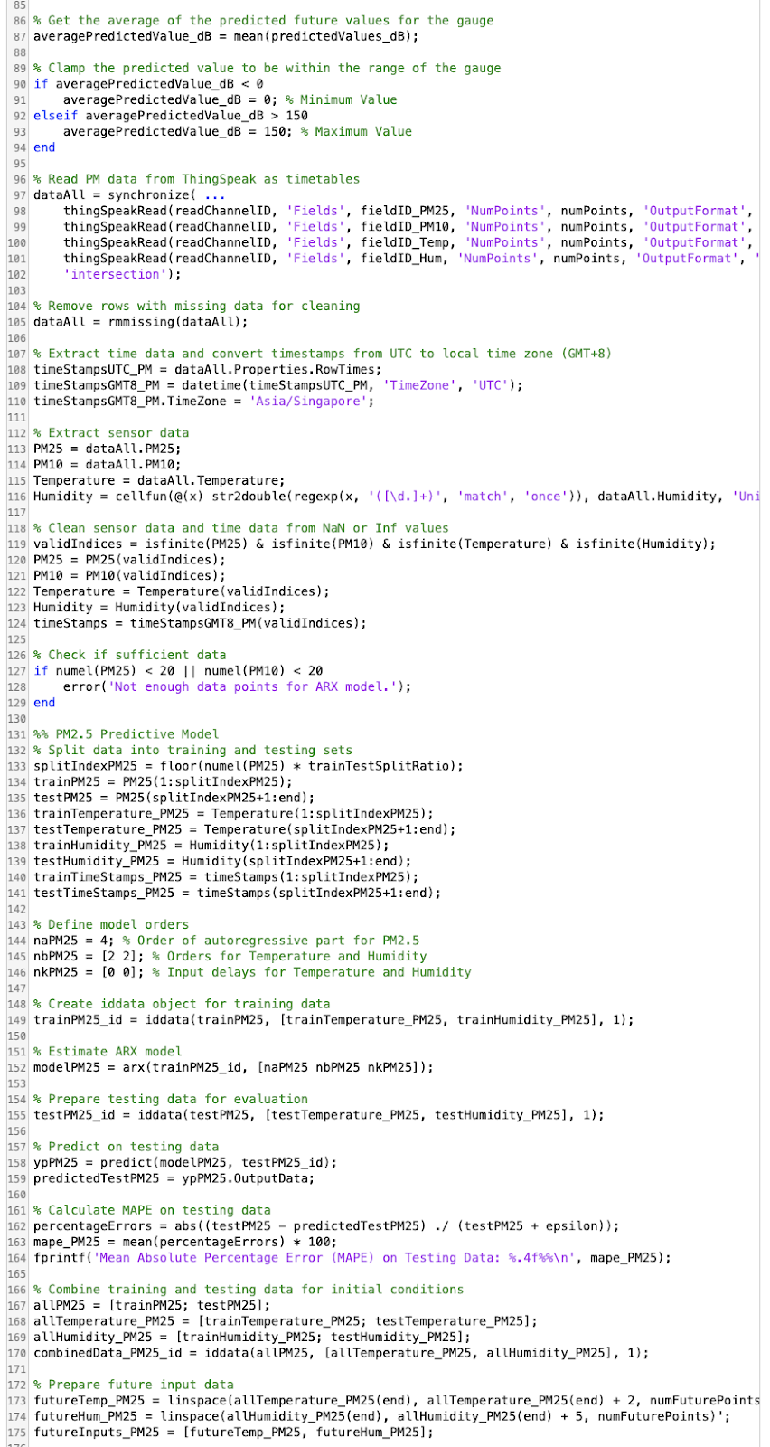

Figure Code for Average Predicted Value Gauges for Sound, PM2.5 &PM10 Part 3

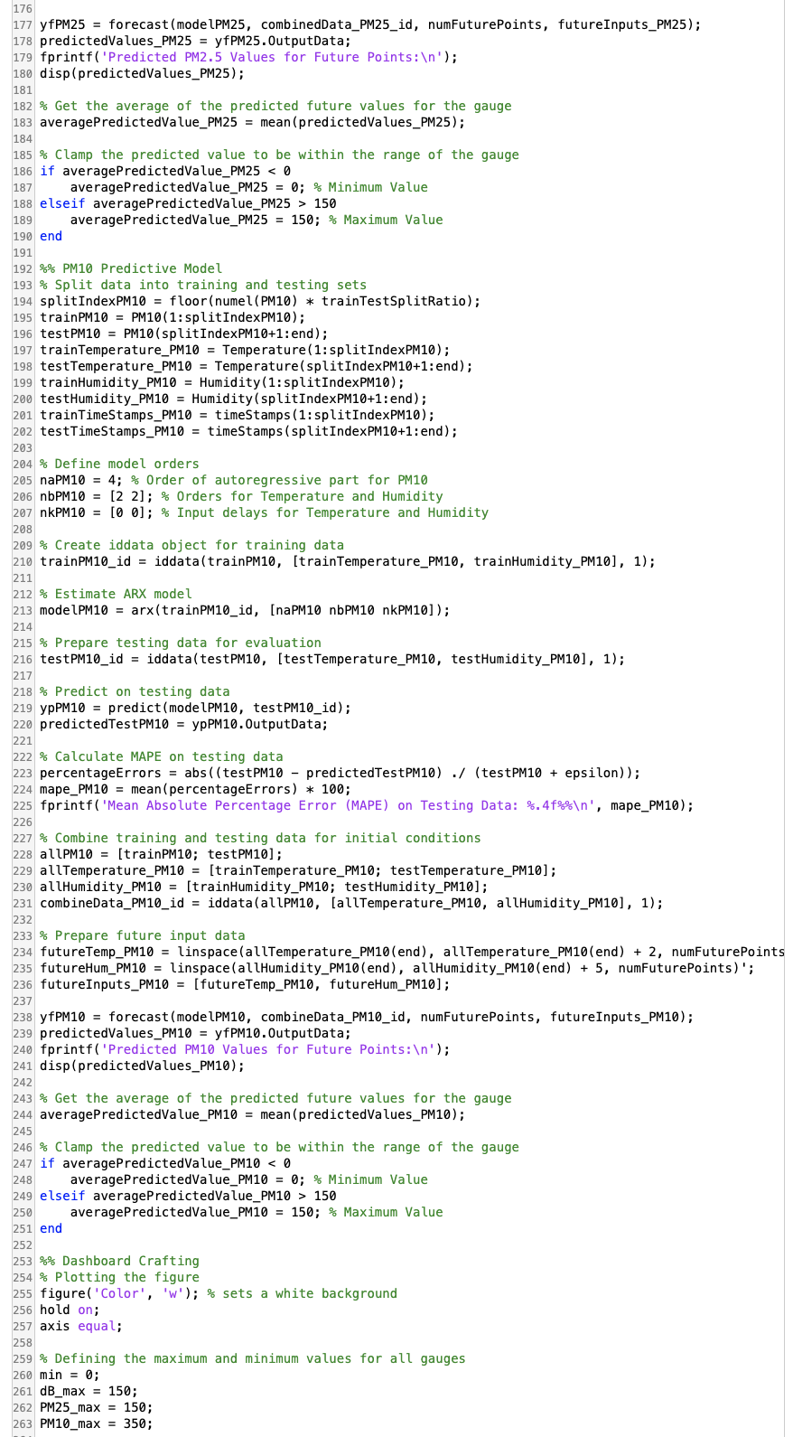

Figure - Code for Average Predicted Value Gauges for Sound, PM2.5 &PM10 Part 4



Figure - Code for Average Predicted Value Gauges for Sound, PM2.5 &PM10 Part 5

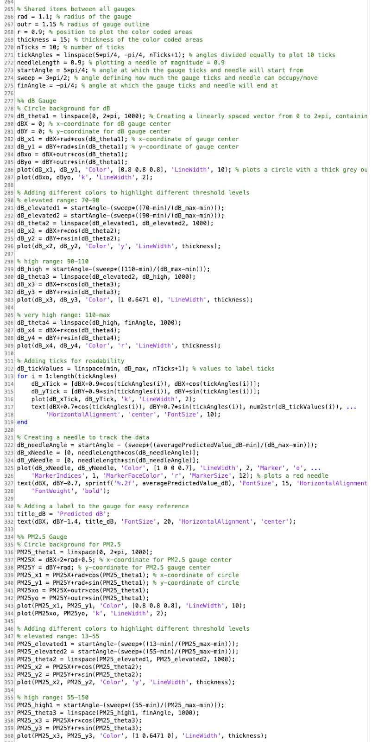

Figure - Code for Average Predicted Value Gauges for Sound, PM2.5 &PM10 Part 6

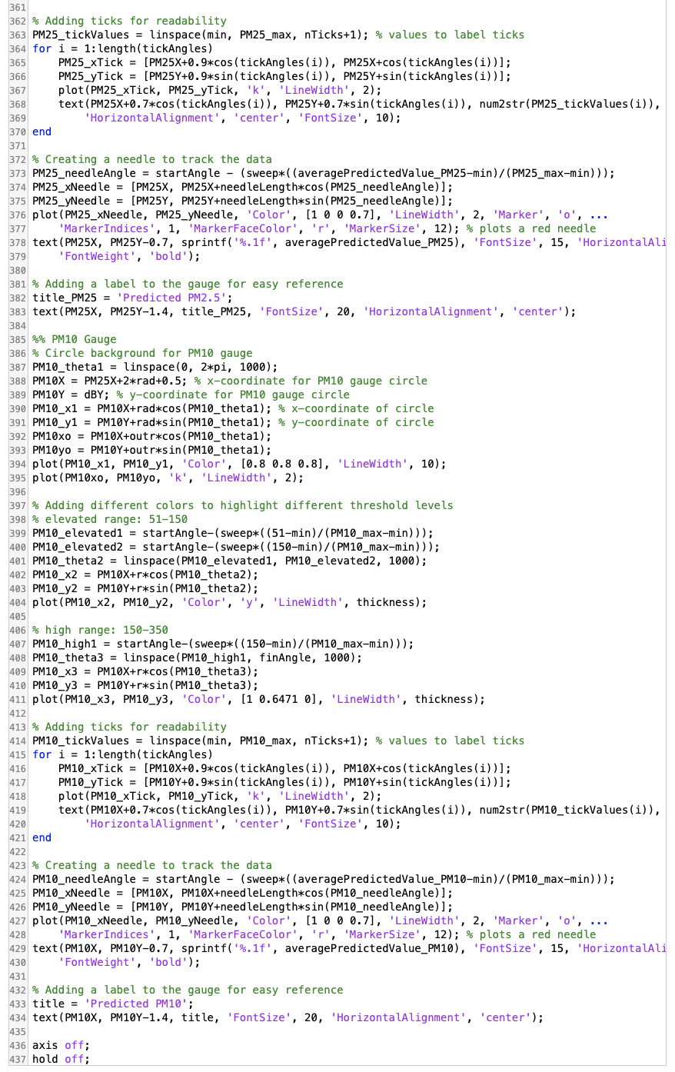

Figure - Code for Average Predicted Value Gauges for Sound, PM2.5 &PM10 Part 7

#include <Arduino.h>

#include <WiFiClientSecure.h> // used for telegram and ESP

#include <WiFiClient.h>       // used for TS

#include <ESP8266WiFi.h>

#include <Adafruit_Sensor.h>

#include <Adafruit_BME280.h>

#include <SoftwareSerial.h> // used for PMS7003

#include <ArduinoJson.h>    // needed for Telebot library to work

#include <UniversalTelegramBot.h>

#include "ThingSpeak.h"

#define SoundSensorPin A0 // SEN0232 Pin

#define VREF 3            // voltage supplied to SEN0232 (db Sensor)

#define PMS7003_TX 12 // D6

#define PMS7003_RX 14 // D5

#define PMS7003_PREAMBLE_1 0x42 // From PMS7003 datasheet

#define PMS7003_PREAMBLE_2 0x4D

#define PMS7003_DATA_LENGTH 31

#define BotToken "XXX" // https://t.me/SmartEnviroBot

SoftwareSerial _serial(PMS7003_TX, PMS7003_RX); // RX,TX

Adafruit_BME280 bme; // BME280 library (temp,humid sensor)

String tele_Message; // messages to send to user

unsigned long bot_lasttime;          // last time messages' scan has been done

const unsigned long BOT_MTBS = 1000; // no idea i copy from somewher

unsigned long last_UploadTime;

const unsigned long uploadInterval = 600000; // can change for showcase

unsigned long lastCheckHazardTime;

const unsigned long checkHazard = 10000; // check environment every 10s for any hazardous levels

unsigned long lastHazardMessageTime;

const unsigned long hazardMessageInterval = 600000; // can change for showcase // 10mins interval for hazard alerts

bool hazardMessageSent = false;                     // used to not spam the user for hazard alerts

int _pm1, _pm25, _pm10; // variables to store data after reading from sensors

float _dB;

float _temperature, _humidity;

// const char* ssid = "Sean";

// const char* password = "XXX"; //my phone hotspot

const char *ssid = "SHONDO 3544";

const char *password = "XXX"; // laptop hotspot

// const char *ssid = "TP-LINK_0248";

// const char *password = "XXX"; //hall wifi p

unsigned long myWriteChannelNumber = 2649409;   // channel where esp sends data to

unsigned long myReadChannelNumber = 2660664;    // channel to read predicted values

const char *myWriteAPIKey = "XXX"; // api for writing data

const char *myReadAPIKey = "XXX";  // api for reading data

X509List cert(TELEGRAM_CERTIFICATE_ROOT);   // needed for telebot

WiFiClientSecure client;                    // for telebot

WiFiClient TS_client;                       // for thingspeak, cannot use same cause TS wont work

UniversalTelegramBot bot(BotToken, client); // telebot library

int statusCode = 0; // status code to check if data is can read/write. will be used to display error code if there is error that happens

float predicted[3] = {NAN, NAN, NAN}; // pm2.5,pm10,dB // to read data from predicted

void uploadCloud2(float dB, int pm1, int pm25, int pm10, float temp, float humid)

{

  ThingSpeak.setField(1, dB);

  ThingSpeak.setField(2, pm1);

  ThingSpeak.setField(3, pm25);

  ThingSpeak.setField(4, pm10);

  ThingSpeak.setField(5, temp);

  ThingSpeak.setField(6, humid); // set which data is for which field

  int x = ThingSpeak.writeFields(myWriteChannelNumber, myWriteAPIKey);

  if (x == 200)

  {

    Serial.println("Channel update successful.");

  }

  else

  {

    Serial.println("Problem updating channel. HTTP error code " + String(x)); // send error code if have

  }

}

void readTempHumdSensor()

{

  _temperature = bme.readTemperature(); // from examples

  _humidity = bme.readHumidity();

  Serial.print("Temperature: ");

  Serial.print(_temperature);

  Serial.println("  °C");

  Serial.println();

  Serial.print("Humidity: ");

  Serial.print(_humidity);

  Serial.println("  %");

  Serial.println();

}

void readdBSensor()

{

  float voltageValue;

  voltageValue = analogRead(SoundSensorPin) / 1024.0 * VREF; // from datasheet of sen0232 //VREF is declared on top

  _dB = voltageValue * 50.0;

  Serial.print("dB Value: ");

  Serial.print(_dB);

  Serial.println("  dB");

  Serial.println();

}

void readPMSSensor()

{

  int checksum = 0; // THIS IS COPIED I DONT UNDERSTAND BUT IT WORKS

  unsigned char pms[32] = {

      0,

  };

  /**

   * Search preamble for Packet

   * Solve trouble caused by delay function

   */

  while (_serial.available() &&

         _serial.read() != PMS7003_PREAMBLE_1 &&

         _serial.peek() != PMS7003_PREAMBLE_2)

  {

  }

  if (_serial.available() >= PMS7003_DATA_LENGTH)

  {

    pms[0] = PMS7003_PREAMBLE_1;

    checksum += pms[0];

    for (int j = 1; j < 32; j++)

    {

      pms[j] = _serial.read();

      if (j < 30)

        checksum += pms[j];

    }

    _serial.flush();

    if (pms[30] != (unsigned char)(checksum >> 8) || pms[31] != (unsigned char)(checksum))

    {

      Serial.println("Checksum error");

      return;

    }

    if (pms[0] != 0x42 || pms[1] != 0x4d)

    {

      Serial.println("Packet error");

      return;

    }

    _pm1 = makeWord(pms[10], pms[11]);

    _pm25 = makeWord(pms[12], pms[13]);

    _pm10 = makeWord(pms[14], pms[15]);

  }

  Serial.print("PM1 Value: ");

  Serial.print(_pm1);

  Serial.println("  µg/m³");

  Serial.println();

  Serial.print("PM2.5 Value: ");

  Serial.print(_pm25);

  Serial.println("  µg/m³");

  Serial.println();

  Serial.print("PM10 Value: ");

  Serial.print(_pm10);

  Serial.println("  µg/m³");

  Serial.println();

}

void sendCurrentValuesToUser()

{

  readdBSensor(); // read from sensors

  readPMSSensor();

  readTempHumdSensor();

  tele_Message = "🌡️ *Current Reading :*\n\n";

  tele_Message += "Temperature: " + String(_temperature) + " °C\n";

  tele_Message += "Humidity: " + String(_humidity) + " %\n";

  tele_Message += "PM2.5: " + String(_pm25) + " µg/m³\n";

  tele_Message += "PM10: " + String(_pm10) + " µg/m³\n";

  tele_Message += "Noise Level: " + String(_dB) + " dB\n"; // set tele message

}

void sendPredictedValuesToUser()

{

  for (int i = 0; i < sizeof(predicted); i++) // do for all 3 readings

  {

    while (isnan(predicted[i])) // do while got any NAN still exist

    {

      predicted[i] = ThingSpeak.readFloatField(myReadChannelNumber, i + 1);

      statusCode = ThingSpeak.getLastReadStatus();

      if (statusCode != 200)

      {

        Serial.println("Problem reading channel. HTTP error code " + String(statusCode));

      }

    }

  }

  tele_Message = "🔮 *Predicted Environment!:*\n\n"; // want to try to bold

  tele_Message += "Predicted PM2.5: " + String(predicted[0]) + " µg/m³\n";

  tele_Message += "Predicted PM10: " + String(predicted[1]) + " µg/m³\n";

  tele_Message += "Predicted Noise: " + String(predicted[2]) + " dB\n"; // set tele message

}

void hazardCurrentValues()

{

  tele_Message = "⚠️ Hazardous Levels in the surronding area ⚠️\n"; //replaces the telemessage with hazard message

  if (_dB >= 85 && _dB <= 89.9)

  {

    tele_Message += "Current Readings at " + String(_dB) + " dB!\n" + "Do not be in the area for more than 8 hours!\n" + "Risk of hearing damage!\n";

  }

  if (_dB >= 90 && _dB <= 94.9)

  {

    tele_Message += "Current Readings at " + String(_dB) + " dB!\n" + "Do not be in the area for more than 2 hours!\n" + "Risk of hearing damage!\n";

  }

  if (_dB >= 95 && _dB <= 119.9)

  {

    tele_Message += "Current Readings at " + String(_dB) + " dB!\n" + "Do not be in the area for more than 15 minutes!\n" + "Risk of hearing damage!\n";

  }

  if (_dB >= 120)

  {

    tele_Message += "Current Readings at " + String(_dB) + " dB!\n" + "Area is not safe!\n" + "Immediate Pain and Hearing Damage at highest risk!\n";

  }

  if (_pm25 >= 55.5 && _pm25 <= 150.4)

  {

    tele_Message += "Current Readings at " + String(_pm25) + " µg/m³!\n" + "Currently in Unhealthy range (55.5 - 150.4)!\n" + "Wear a mask if you are sensitive!\n";

  }

  if (_pm25 >= 150.5 && _pm25 <= 250.4)

  {

    tele_Message += "Current Readings at " + String(_pm25) + " µg/m³!\n" + "Currently in Very Unhealthy range (150.5 - 250.4)!\n" + "Highly encouraged to wear a N95 mask!\n";

  }

  if (_pm25 >= 250)

  {

    tele_Message += "Current Readings at " + String(_pm25) + " µg/m³!\n" + "Area is not safe!\nCurrently in Hazardous Range (>250)!" + "Wear a N95 mask or stay indoors!\n";

  }

  if (_pm10 >= 255 && _pm10 <= 354)

  {

    tele_Message += "Current Readings at " + String(_pm10) + " µg/m³!\n" + "Currently in Unhealthy range (255 - 354)!\n" + "Wear a mask if you are sensitive!\n";

  }

  if (_pm10 >= 255 && _pm10 <= 424)

  {

    tele_Message += "Current Readings at " + String(_pm10) + " µg/m³!\n" + "Currently in Very Unhealthy range (255 - 424)!\n" + "Highly encouraged to wear a N95 mask!\n";

  }

  if (_pm10 >= 425)

  {

    tele_Message += "Current Readings at " + String(_pm10) + " µg/m³!\n" + "Area is not safe!\nCurrently in Hazardous Range (>425)!" + "Wear a N95 mask or stay indoors!\n";

  }

  //needed to hardcode this. was damn tiring

  bot.sendMessage("824917767", tele_Message, ""); // exclusive to my chat ONLY. // dont abuse my chatid pls

  hazardMessageSent = true; // if hazard message is sent alrd, set to true so that need to wait 10mins

  lastHazardMessageTime = millis(); // put the timing for the last hazard message

}

void hazardPredictedValues()

{

  tele_Message = "⚠️ Potential Hazardous Levels in the surronding area ⚠️\n"; //replaces the telemessage with hazard message

  if (predicted[2] >= 85 && predicted[2] <= 89.9)

  {

    tele_Message += "Predicted Readings at " + String(predicted[2]) + " dB!\n" + "Do not be in the area for more than 8 hours!\n" + "Risk of hearing damage!\n";

  }

  if (predicted[2] >= 90 && predicted[2] <= 94.9)

  {

    tele_Message += "Predicted Readings at " + String(predicted[2]) + " dB!\n" + "Do not be in the area for more than 2 hours!\n" + "Risk of hearing damage!\n";

  }

  if (predicted[2] >= 95 && predicted[2] <= 119.9)

  {

    tele_Message += "Predicted Readings at " + String(predicted[2]) + " dB!\n" + "Do not be in the area for more than 15 minutes!\n" + "Risk of hearing damage!\n";

  }

  if (predicted[2] >= 120)

  {

    tele_Message += "Predicted Readings at " + String(predicted[2]) + " dB!\n" + "Area is not safe!\n" + "Immediate Pain and Hearing Damage at highest risk!\n";

  }

  if (predicted[0] >= 55.5 && predicted[0] <= 150.4)

  {

    tele_Message += "Predicted Readings at " + String(predicted[0]) + " µg/m³!\n" + "Predicted readings at Unhealthy range (55.5 - 150.4)!\n" + "Wear a mask if you are sensitive!\n";

  }

  if (predicted[0] >= 150.5 && predicted[0] <= 250.4)

  {

    tele_Message += "Predicted Readings at " + String(predicted[0]) + " µg/m³!\n" + "Predicted readings at Very Unhealthy range (150.5 - 250.4)!\n" + "Highly encouraged to wear a N95 mask!\n";

  }

  if (predicted[0] >= 250)

  {

    tele_Message += "Predicted Readings at " + String(predicted[0]) + " µg/m³!\n" + "Area is not safe!\nPredicted readings at Hazardous Range (>250)!" + "Wear a N95 mask or stay indoors!\n";

  }

  if (predicted[1] >= 255 && predicted[1] <= 354)

  {

    tele_Message += "Predicted Readings at " + String(predicted[1]) + " µg/m³!\n" + "Predicted readings at Unhealthy range (255 - 354)!\n" + "Wear a mask if you are sensitive!\n";

  }

  if (predicted[1] >= 255 && predicted[1] <= 424)

  {

    tele_Message += "Predicted Readings at " + String(predicted[1]) + " µg/m³!\n" + "Predicted readings at Very Unhealthy range (255 - 424)!\n" + "Highly encouraged to wear a N95 mask!\n";

  }

  if (predicted[1] >= 425)

  {

    tele_Message += "Predicted Readings at " + String(predicted[1]) + " µg/m³!\n" + "Area is not safe!\nPredicted readings at Hazardous Range (>425)!" + "Wear a N95 mask or stay indoors!\n";

  }

  bot.sendMessage("XXX", tele_Message, ""); //removed chatID

  hazardMessageSent = true; //same as current hazard

  lastHazardMessageTime = millis();

}

void handleNewMessages(int numNewMessages)

{

  //referred from the telebot library

  Serial.print("handleNewMessages ");

  Serial.println(numNewMessages);

  for (int i = 0; i < numNewMessages; i++)

  {

    String chat_id = bot.messages[i].chat_id; //get the user chatid

    String text = bot.messages[i].text; //reads the user command

    if (text == "/start") //show all other commands with keyboard

    {

      String keyboardJson = "[[\"/Current\", \"/Predicted\"]]"; //keyboard design

      tele_Message = "Welcome to Smart Monitoring System (Noise & Dust)\nWhat do you want to see?\n";

      tele_Message += "/Current : Show the current environment Particulate Matter & dB\n";

      tele_Message += "/Predicted : Show the predicted environment Particulate Matter & dB\n";

      bot.sendMessageWithReplyKeyboard(chat_id, tele_Message, "", keyboardJson, true); //send messsage with keyboard. no idea why the true is there tho

    }

    if (text == "/Current") //send current values

    {

      sendCurrentValuesToUser(); //reads current values

      String keyboardJson = "[[{ \"text\" : \"Current Gauges\", \"url\" : \"https://thingspeak.mathworks.com/apps/matlab_visualizations/586875?height=auto&width=auto\" }]]"; //add the url below message

      bot.sendMessageWithInlineKeyboard(chat_id, tele_Message, "Markdown", keyboardJson); //send message with url

    }

    if (text == "/Predicted")

    {

      sendPredictedValuesToUser(); //reads predicted values //same as above just predicted

      String keyboardJson = "[[{ \"text\" : \"Predicted Gauges\", \"url\" : \"https://thingspeak.mathworks.com/apps/matlab_visualizations/587793?height=auto&width=auto\" }]]";

      bot.sendMessageWithInlineKeyboard(chat_id, tele_Message, "Markdown", keyboardJson); //same as above

    }

  }

}

void setup()

{

  // put your setup code here, to run once:

  Serial.begin(9600);

  _serial.begin(9600);

  bme.begin(0x76);

  configTime(0, 0, "pool.ntp.org");

  client.setTrustAnchors(&cert);

  Serial.println("Connecting to ");

  Serial.println(ssid);

  WiFi.begin(ssid, password);

  while (WiFi.status() != WL_CONNECTED)

  {

    delay(500);

    Serial.print(".");

  }

  // print a new line, then print WiFi connected and the IP address

  Serial.println("");

  Serial.println("WiFi connected");

  // Print the IP address

  // Serial.println(WiFi.localIP());

  // bot.begin();

  ThingSpeak.begin(TS_client);

}

void loop()

{

  if (millis() - bot_lasttime > BOT_MTBS) //every 1sec scan for message

  {

    int numNewMessages = bot.getUpdates(bot.last_message_received + 1); //reads last message

    while (numNewMessages) //copied from example

    {

      Serial.println("got response");

      handleNewMessages(numNewMessages);

      numNewMessages = bot.getUpdates(bot.last_message_received + 1); //no clue the +1

    }

    bot_lasttime = millis();

  }

  if (millis() - last_UploadTime >= uploadInterval) //only do every 10mins, lmk if dont unds this

  {

    readdBSensor();

    readPMSSensor();

    readTempHumdSensor();

    uploadCloud2(_dB, _pm1, _pm25, _pm10, _temperature, _humidity);

    last_UploadTime = millis();

  }

  if (millis() - lastCheckHazardTime >= checkHazard) //do every 10sec

  {

    readdBSensor();

    readPMSSensor();

    sendPredictedValuesToUser();

    if ((_dB >= 85.0 || _pm25 >= 55.5 || _pm10 >= 255.0) && !hazardMessageSent) //this is for hazard values, last part of the condition is to avoid spamming //if hazardmsg is sent, then hazardmessage is True making this if not to work

    {

      hazardCurrentValues();

    }

    else

    {

      if (millis() - lastHazardMessageTime >= hazardMessageInterval) //after 10mins then hazardmessagesent is set to false so means can send hazard message again if still got hazardvalues around

      {

        hazardMessageSent = false;

      }

    }

    if (predicted[2] >= 85.0 || predicted[0] >= 55.5 || predicted[1] >= 255.0) //just for general checking every 10s

    {

      hazardPredictedValues();

    }

    else

    {

      if (millis() - lastHazardMessageTime >= hazardMessageInterval) //same as the above

      {

        hazardMessageSent = false;

      }

    }

    lastCheckHazardTime = millis(); //go online to see what is millis() if dont understand

  }

}

Figure 61 – Arduino Code with ThingSpeak, TeleBot integrated